LAB 01 Practise

1 Login to AWS portal with IAM account abd portal region to N Virginia

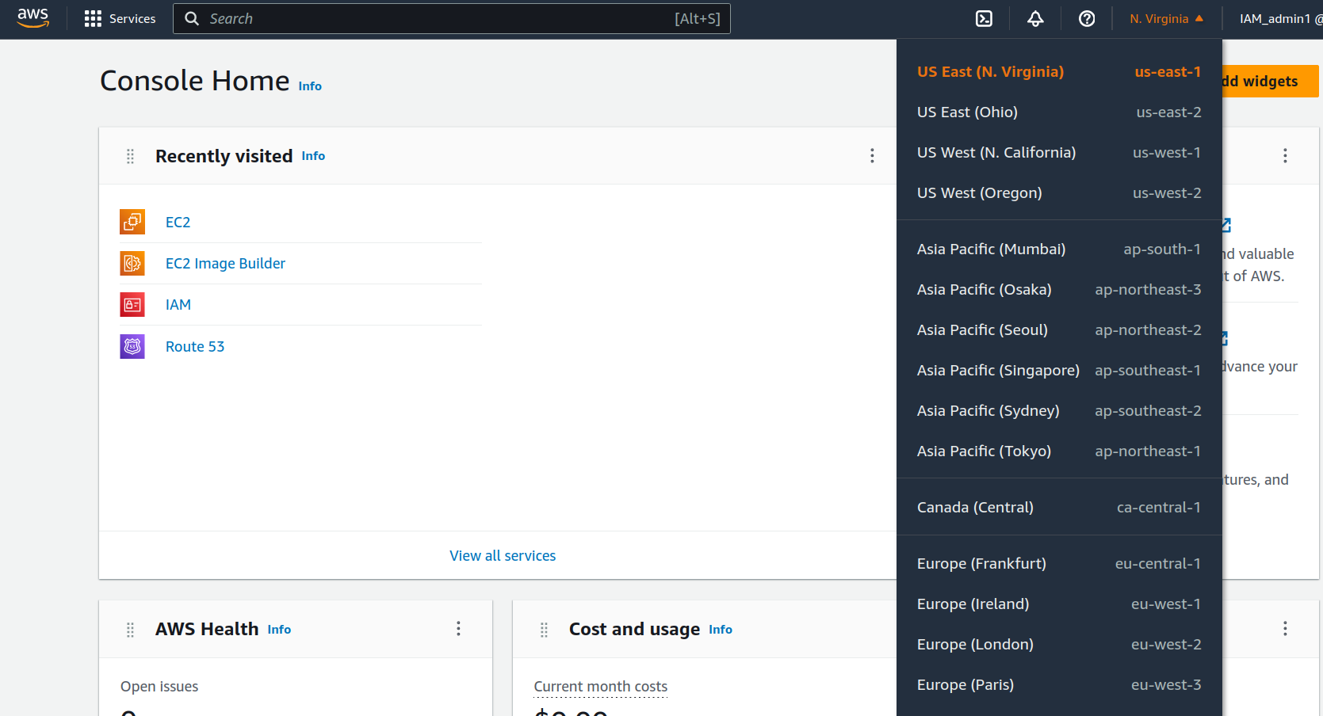

2. Create an Instance from the **EC2** menue following the steps below.

Click on “**EC2**” > Instances menue > Launch Instances

Fill in the Name field with desired name and select “Ubuntu” under quick start options

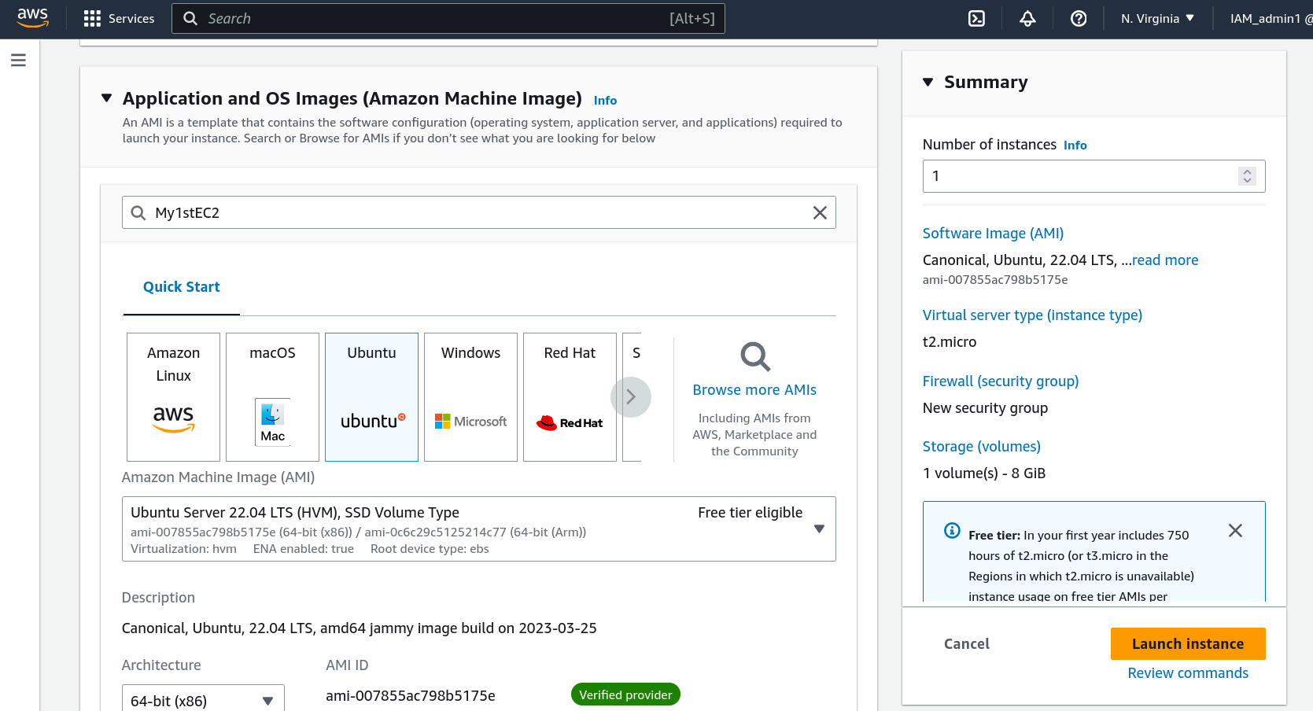

Under “key Pair Login” click on create new key pair.

Specify a name for keypair and click on “create key pair” to download a .pem file

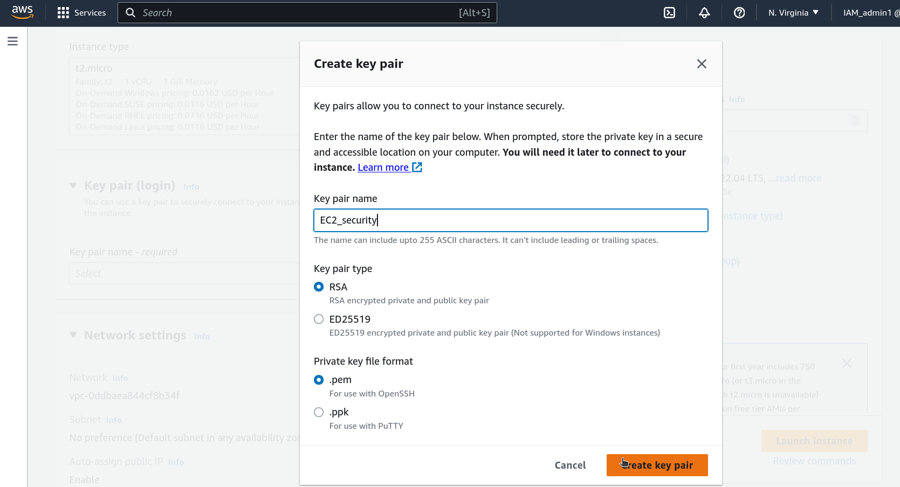

Click on edit button under **Network Settings**

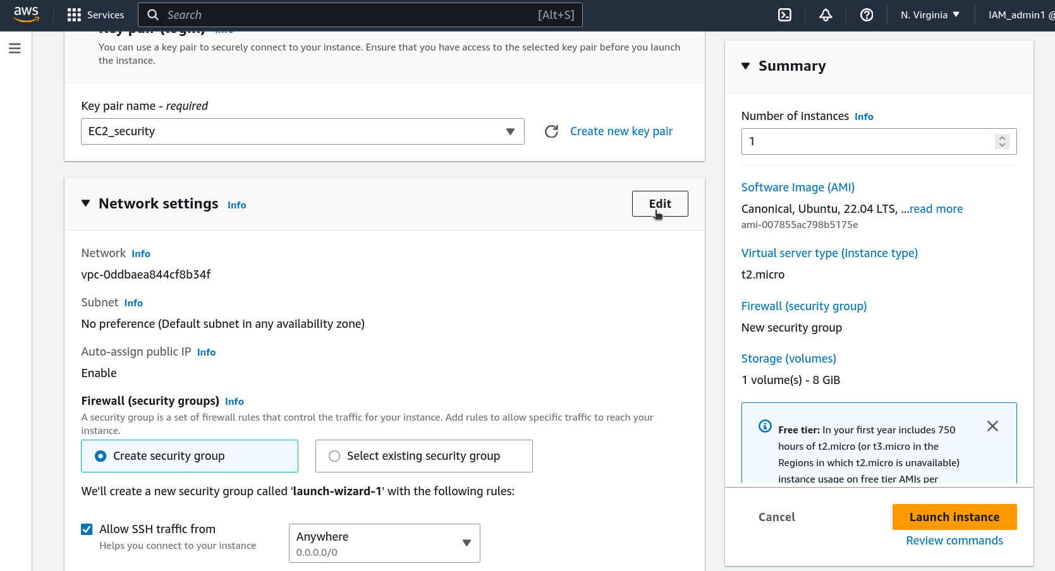

Scroll down and add a security group with bellow configuration

Type = HTTP

Source = Custom

Source = 0.0.0.0

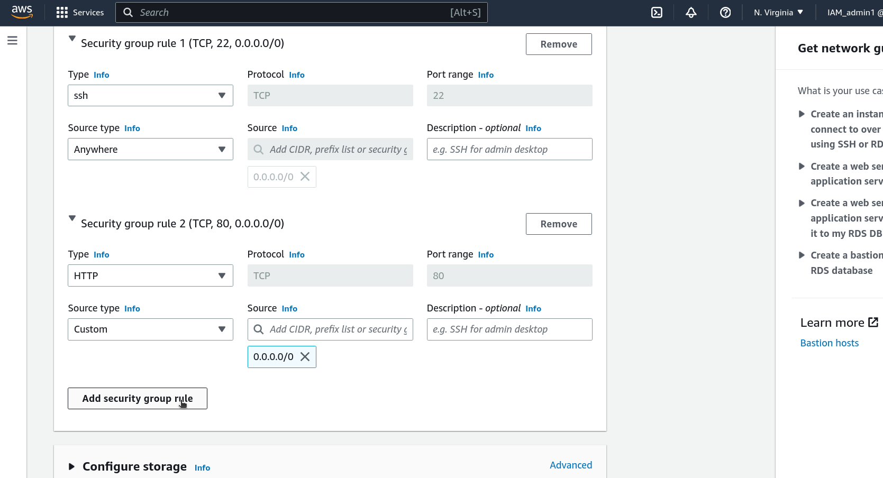

Click on **Launch instance** and return to the Instance dashboard menue

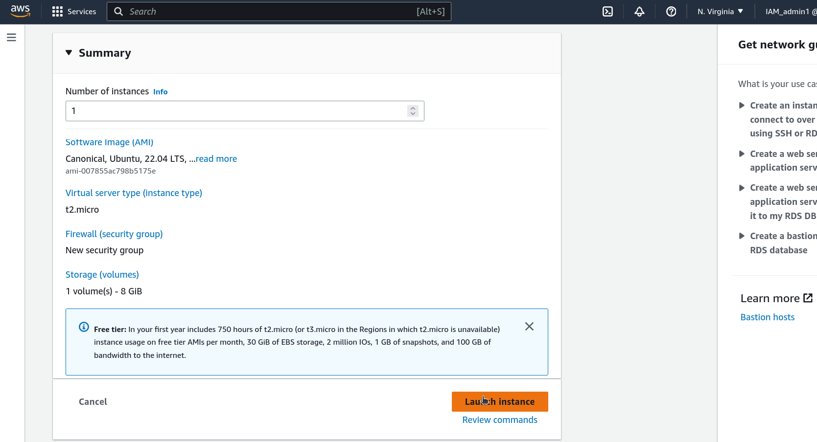

Visit the Instance Menu to view the list of instances created

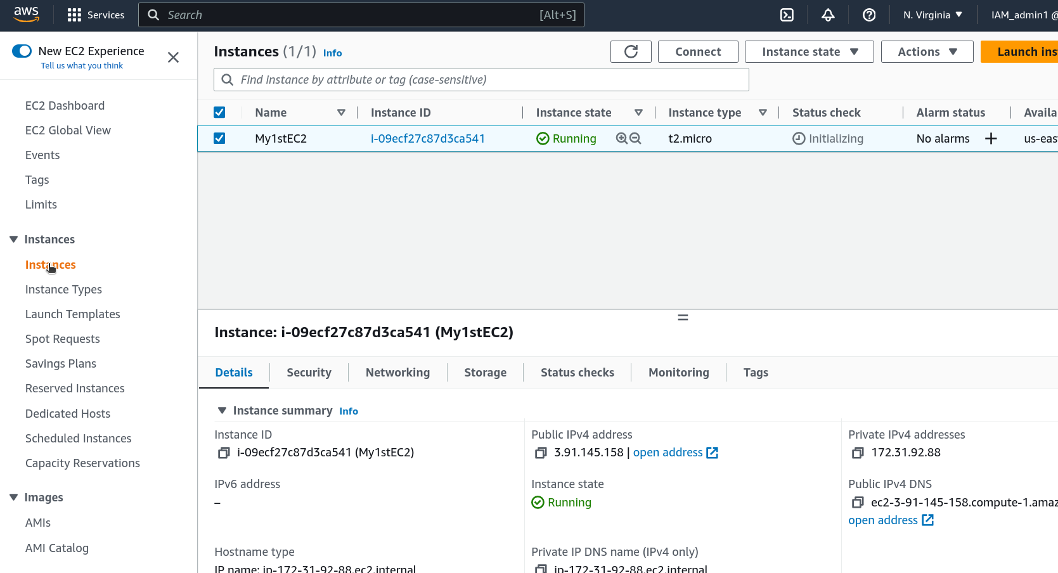

Congratulation an instance has been successfully created

Minimize the Browser window and open the Linux Terminal

Change the directory to the folder where the **.pem** file has been saved.

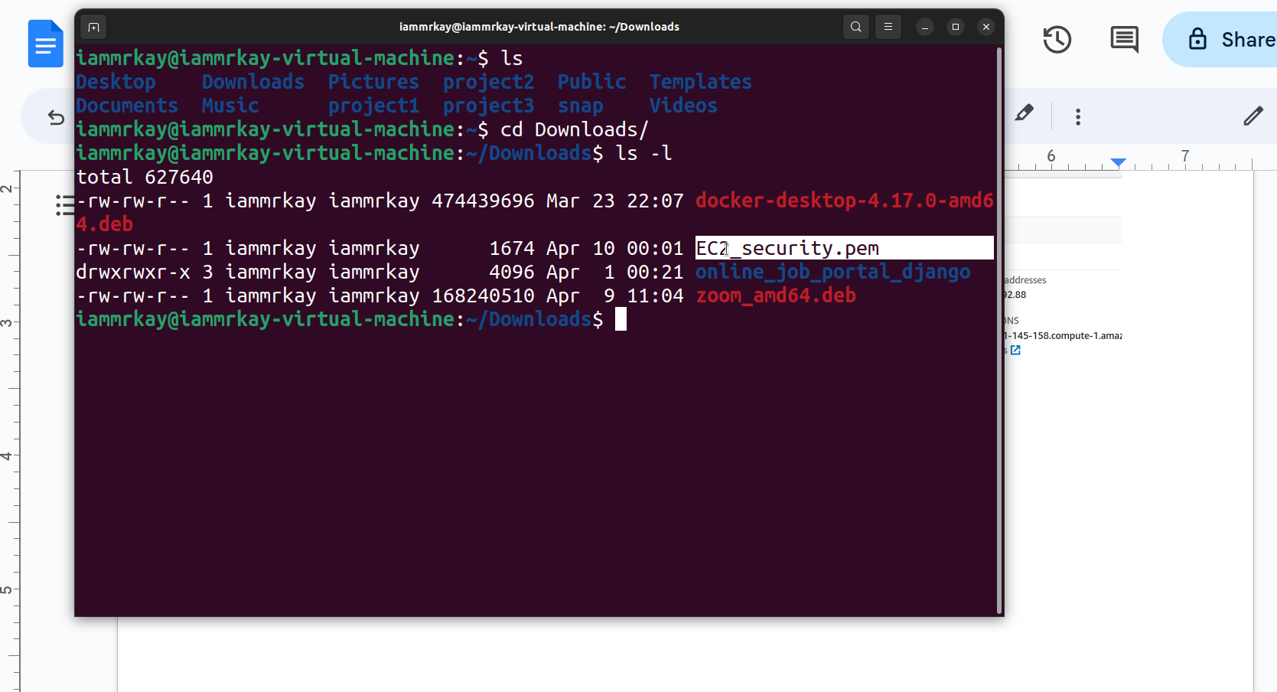

Change the permissions of the **.pem** file by entering the following code.

>chmod 400 [filename.pem]

(replace the filename accordingly)

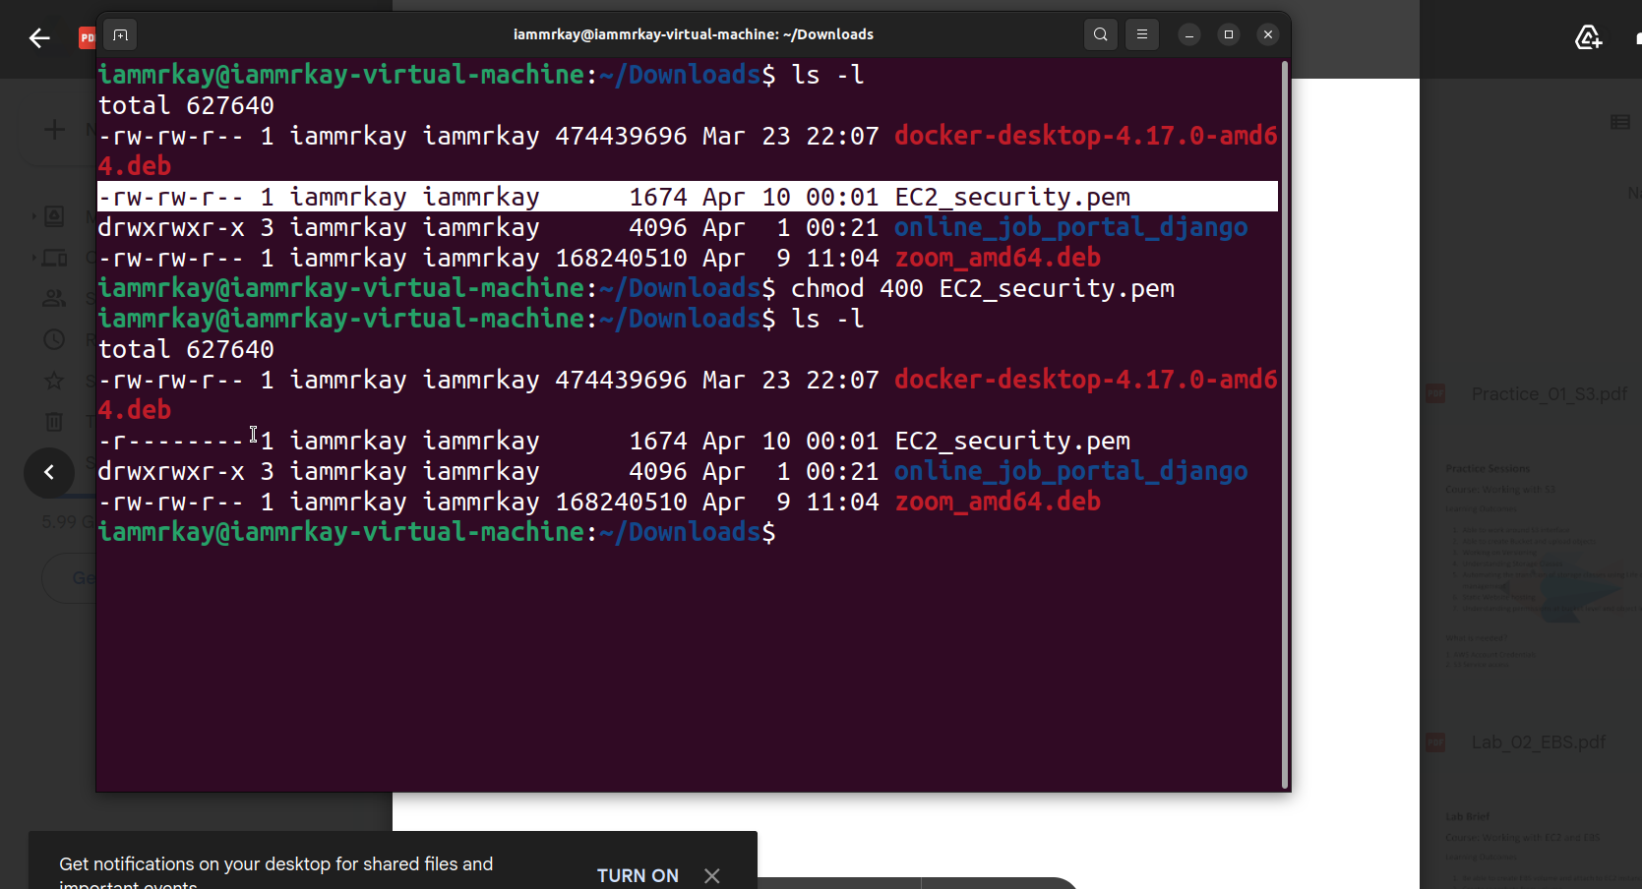

Enter the following command to connect to the **EC2** instance through the terminal

>ssh -i [filename.pem] ubuntu@[public IP address]

(the public IP address can be found in the Details section under instance summary)

Type “yes” and click on enter

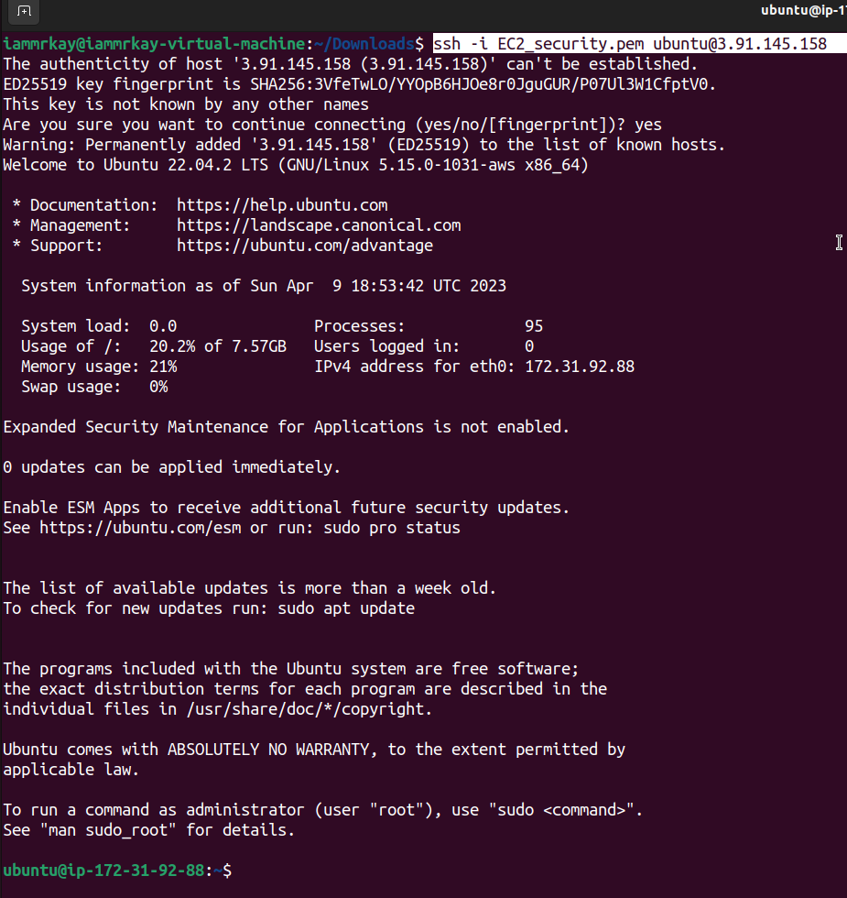

Congratulations, you have successfully connected to the **EC2** instance through the Linux Terminal.

Enter the following commands to update the linux repository instance the EC2 instance and install Apache server

>sudo apt-get update

>sudo apt-get install apache2

Congratulations you have successfully update the repository in the EC2 instance and installed Apache server.

Open a new browser tab and enter the public IP address

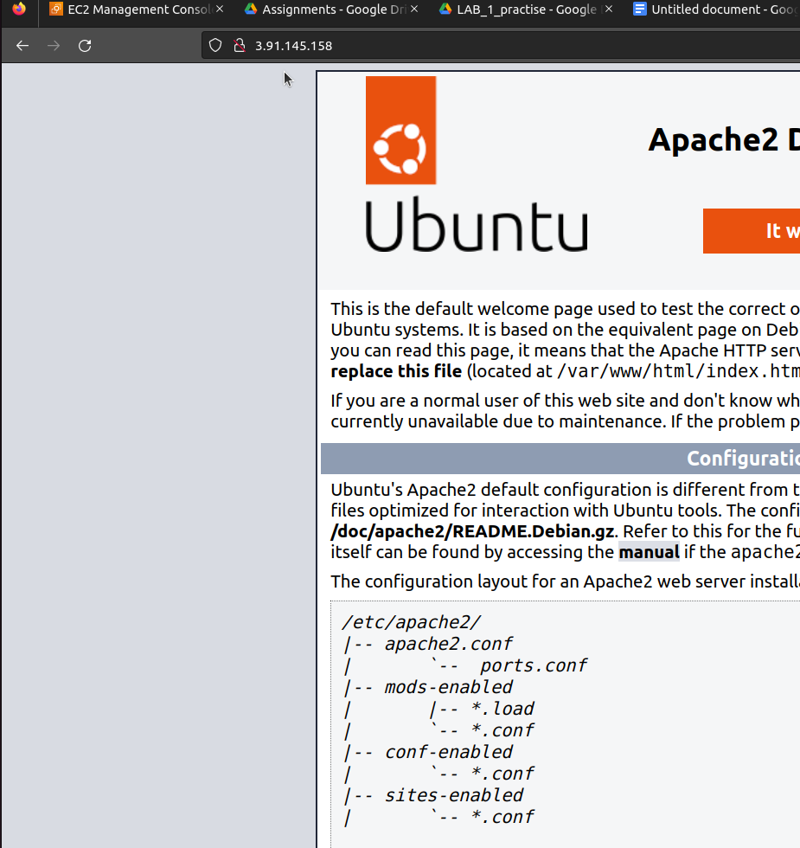

Congratulations your apache server is functional and accessible in the EC2 instance

Now visit the **Instance** menu and stop the running instance by selecting the instance , clicking on actions button and selecting **Stop Instance** .

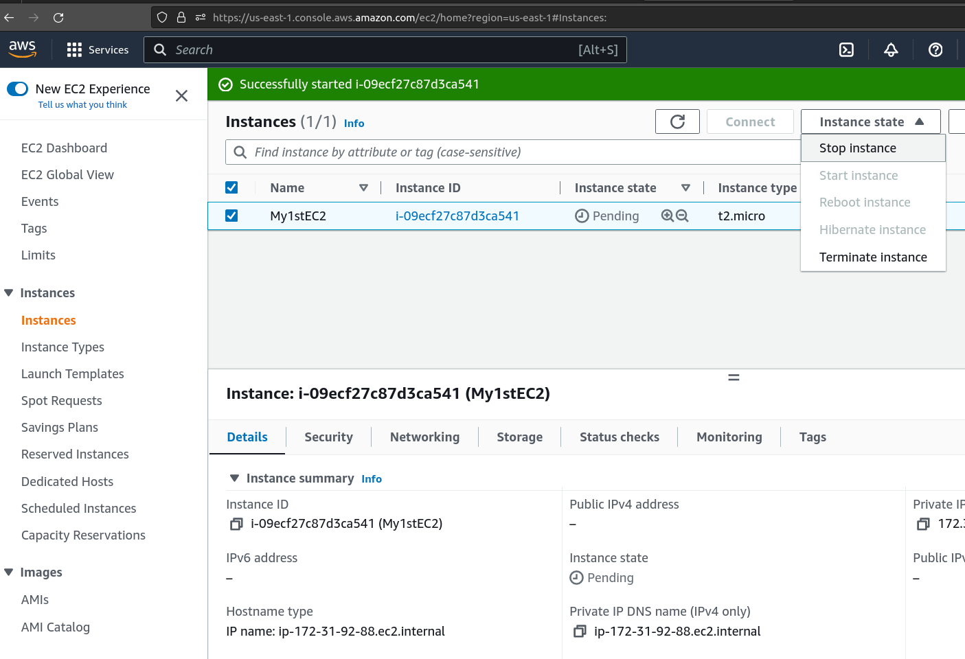

To create an Amazon Machine Image (AMI),

Visit the **Volume** sub-menu under **Elastic Bean Stock**

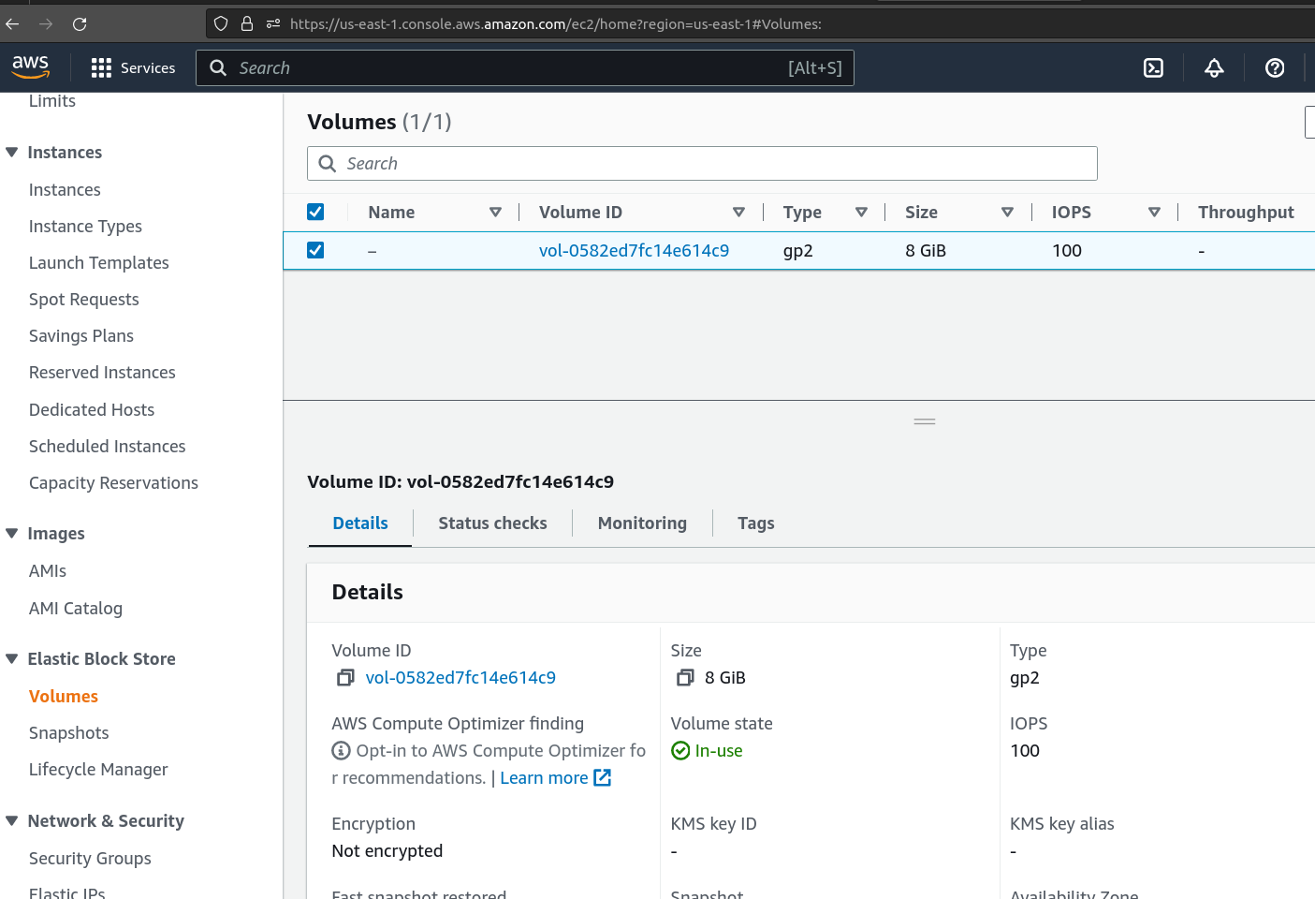

If you have successfully created the instance like earlier, you would find a volume attached to the instance reflecting as shown above.

Select the Volume and click on the **Actions** button to create a **snapshot** as shows below

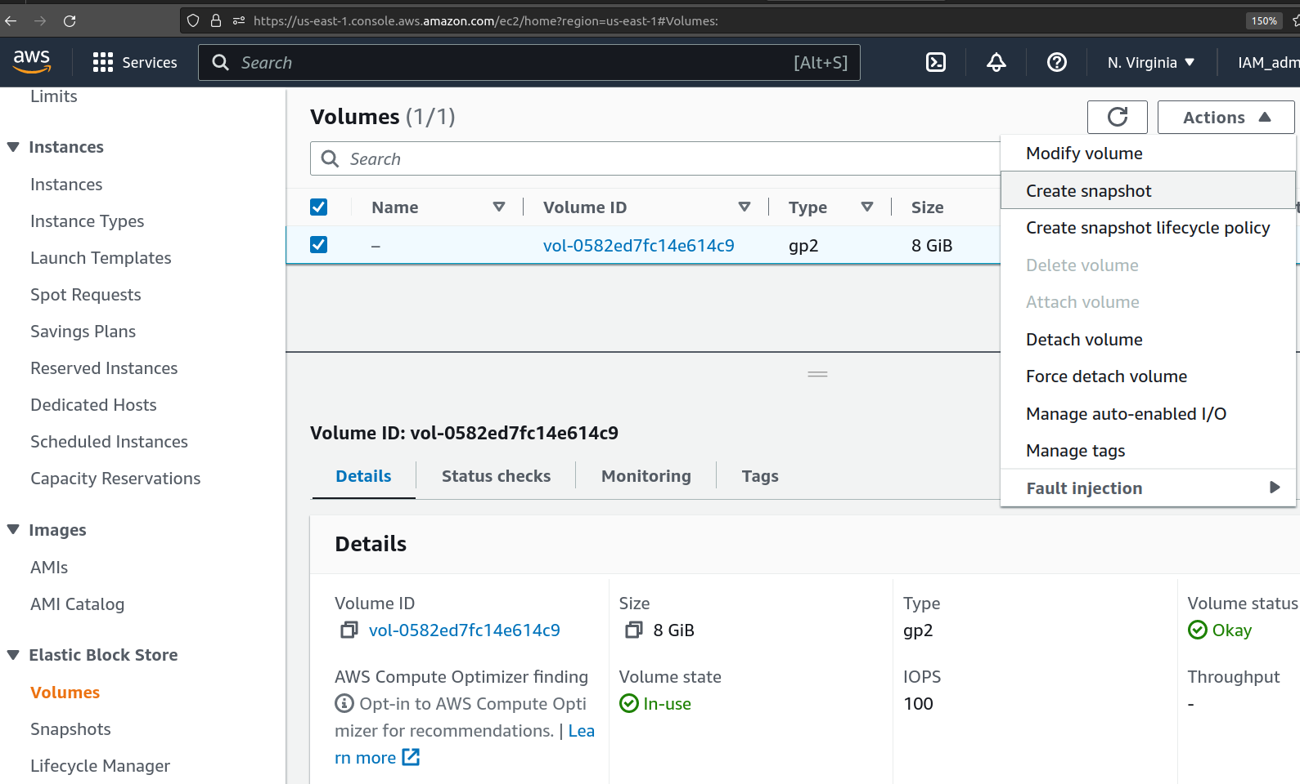

Specify a name for the snapshot and click on **Create Snapshot**

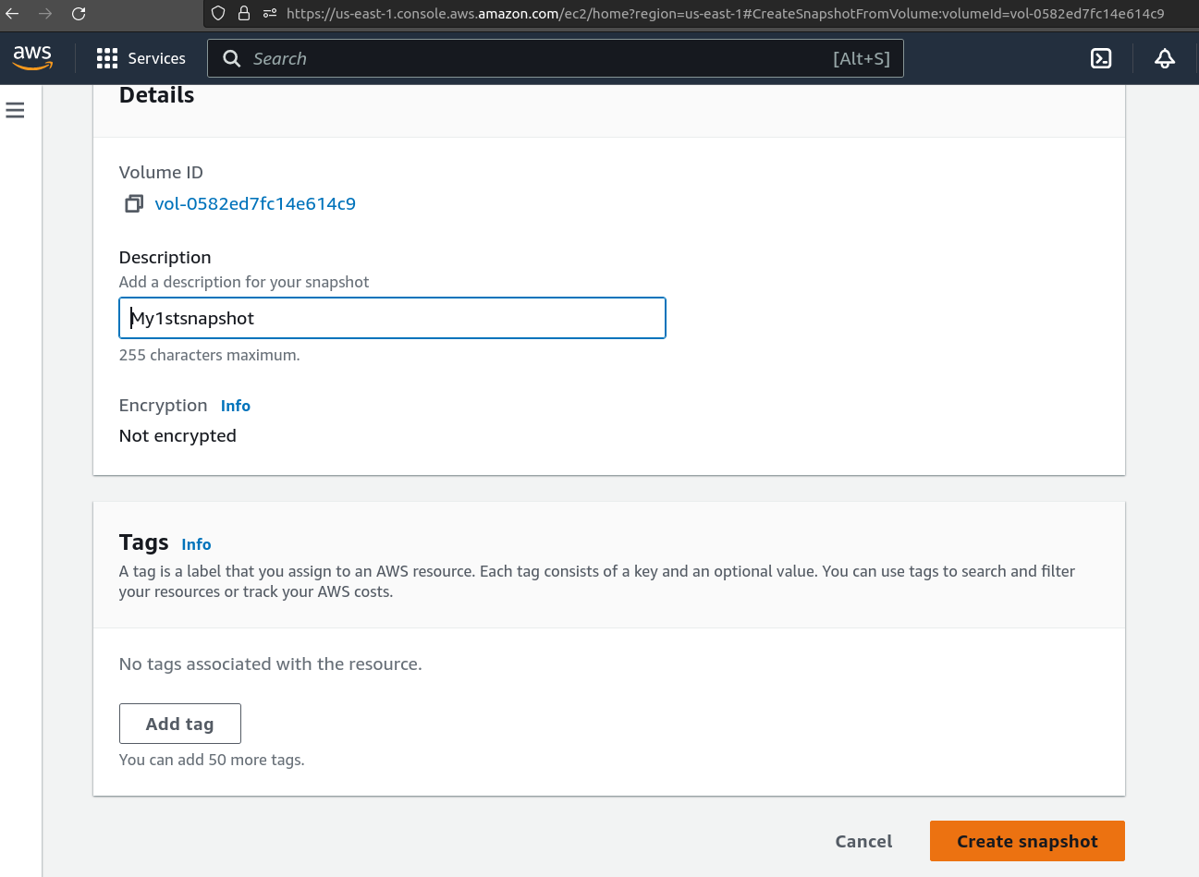

Few minutes later you will find a snapshot reflecting in the **Snapshot** menu under **Elastic Bean Stock**

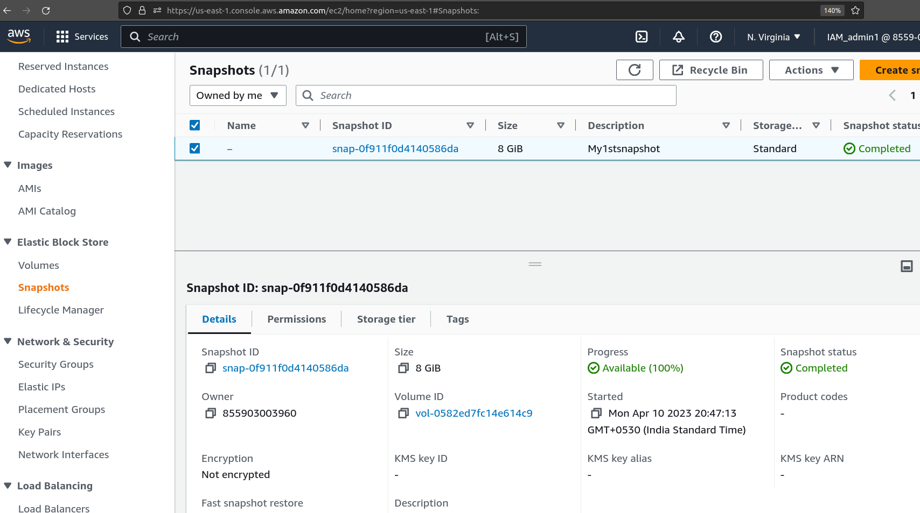

Make sure snapshot status is reflecting in completed status as shown above.

Select the Snapshot by ticking the checkbox to the left of the snapshot and click on **Actions** button as shown below.

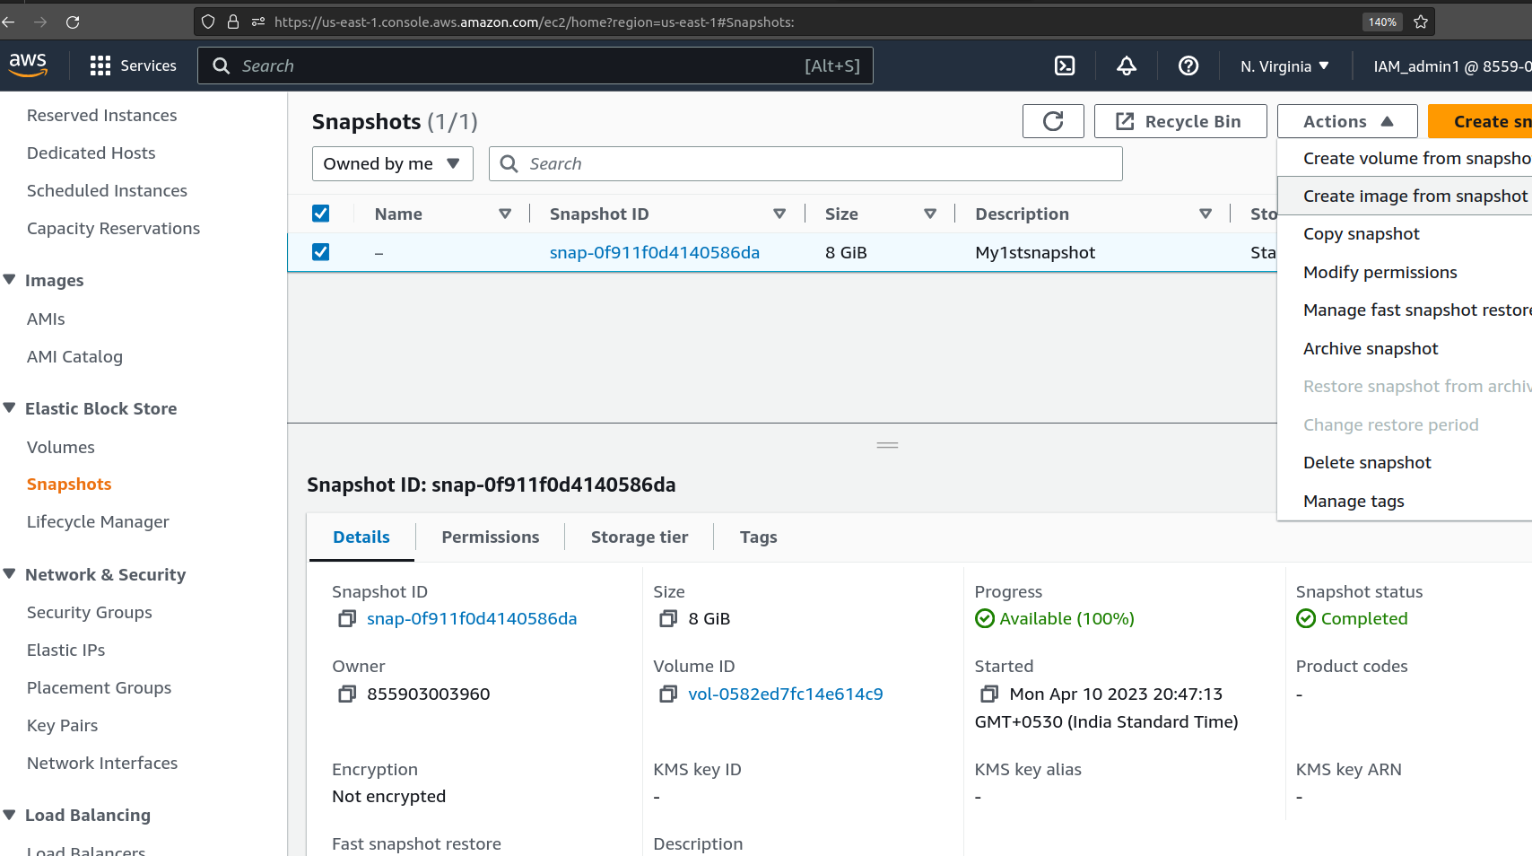

Click on **Create image from Snapshot** and the below wizard will appear

Specify an imagename in the Image name field and click on **Create Image** at the bottom of the page.

Visit the **AMI** sub-menue under **Images** and the newly created AMI would be reflecting in the list as shown below.

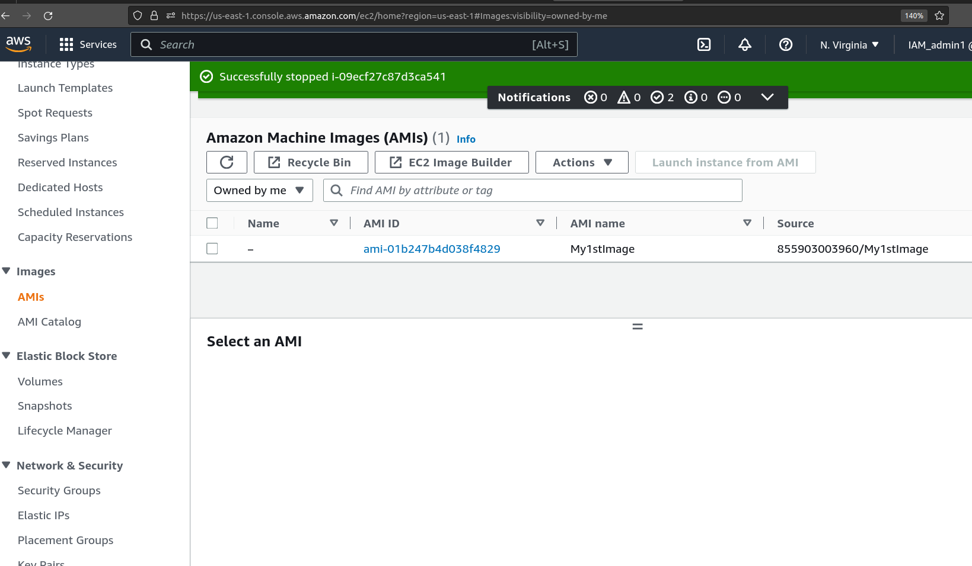

Congratulations you have created an AMI from a snapshot of an existing instance.

Visit the **Instance** menu and click on **Launch an Instance**

Specify your desired name and select **My AMIs**

You will find your recently created **AMI** reflecting in the Amazon Machine Image (AMI) dropdown menu.

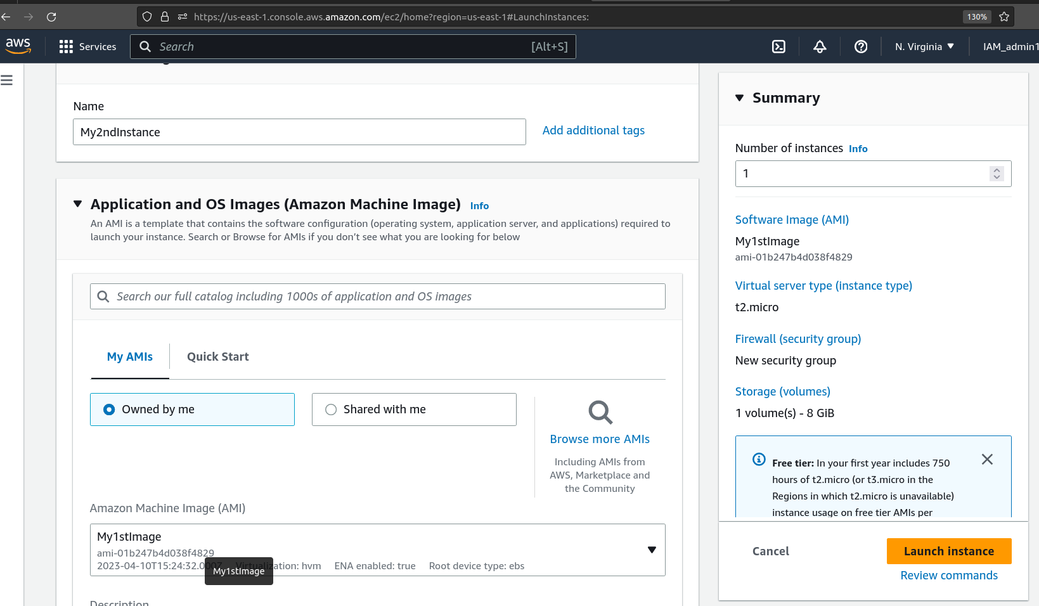

Select your AMI and scroll down to the **Network Settings** sections.

Select a key pair which had created earlier.

Click on **Edit** button in the **Network Setting** sections.

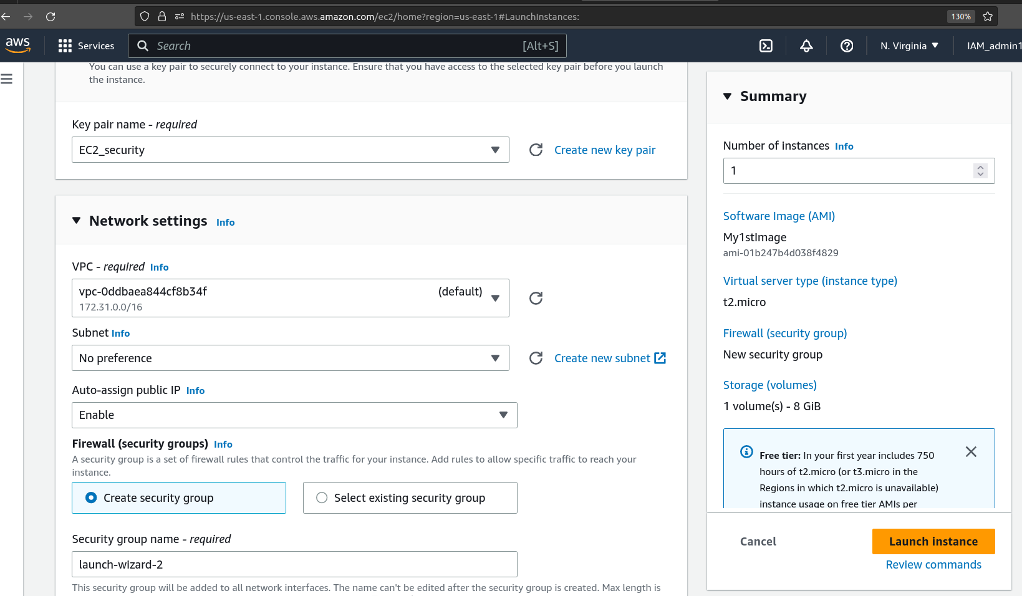

Scroll down and click on **Add security group rule** button.

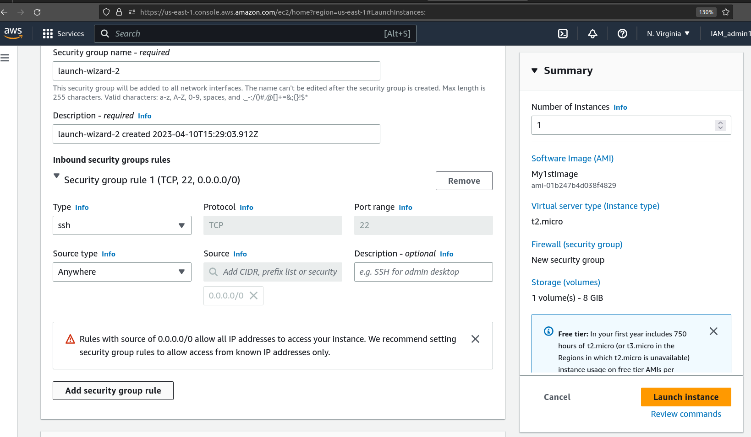

Enter -

Type + HTTP

Server type + Custome

Sourcee + 0.0.0.0

Click on **Launch Instance**

Congratulations you have successfully created an instance with your own AMI.

Visit the Instance menu to confirm the same.

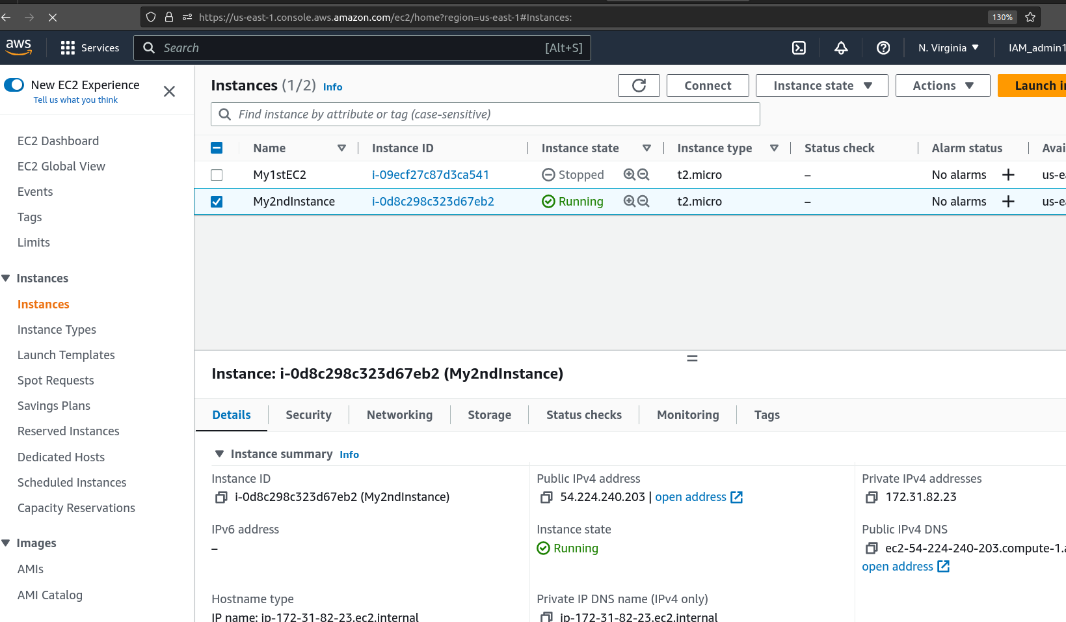

Select the Instance and click on connect as shown below

(make sure the instance is in running status)

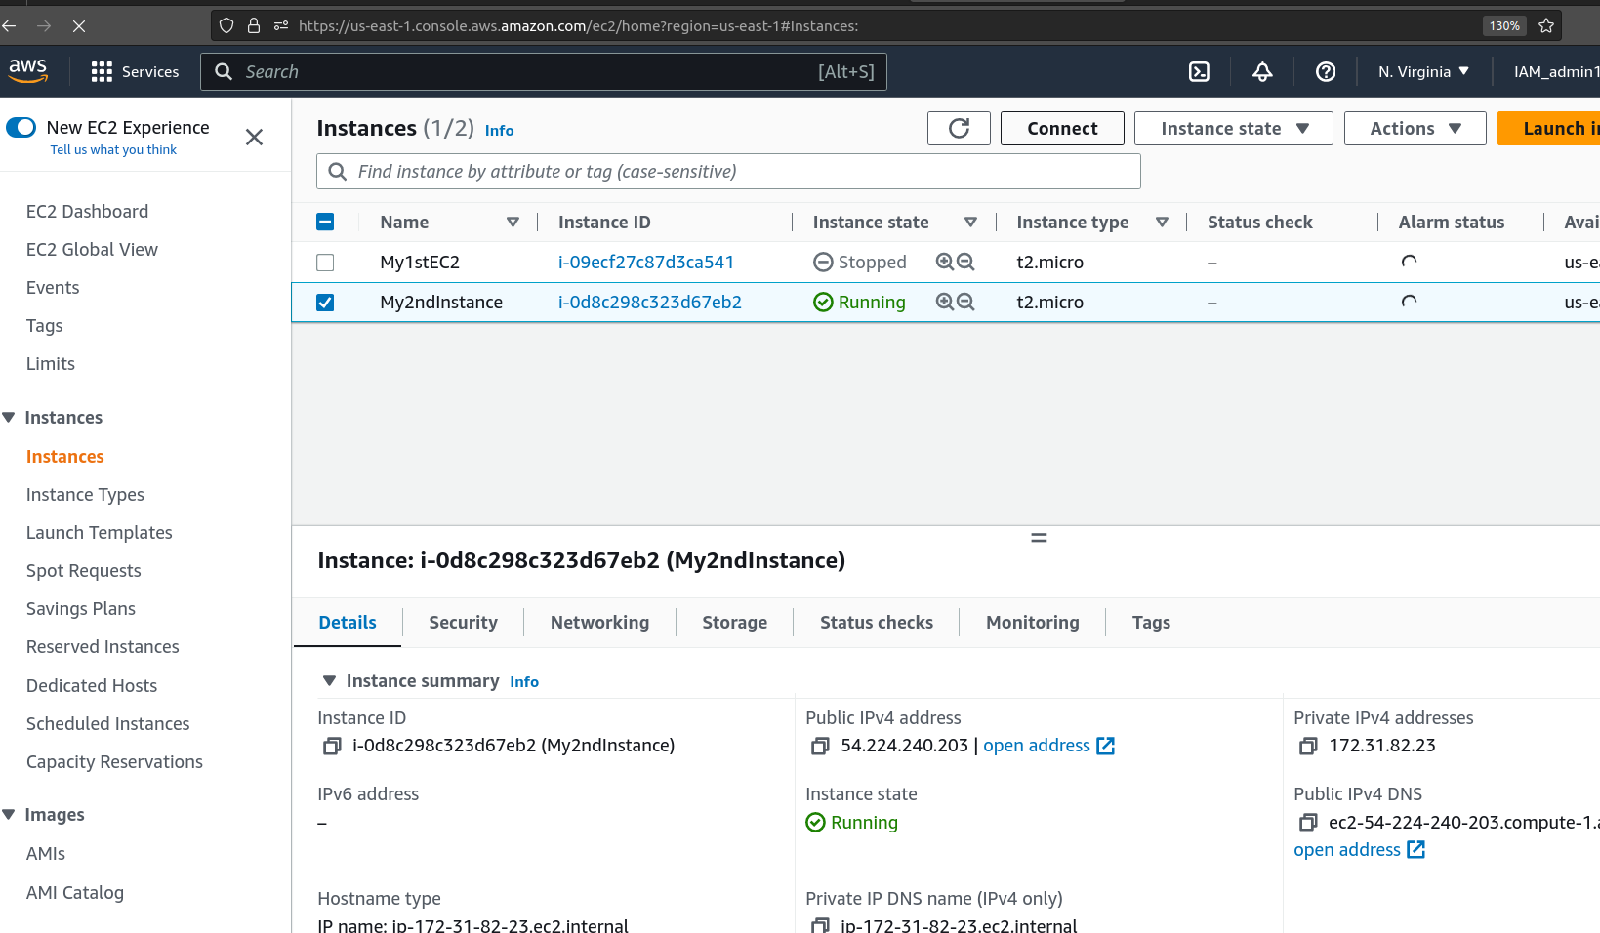

A connect to instance wizard would appear as shown below

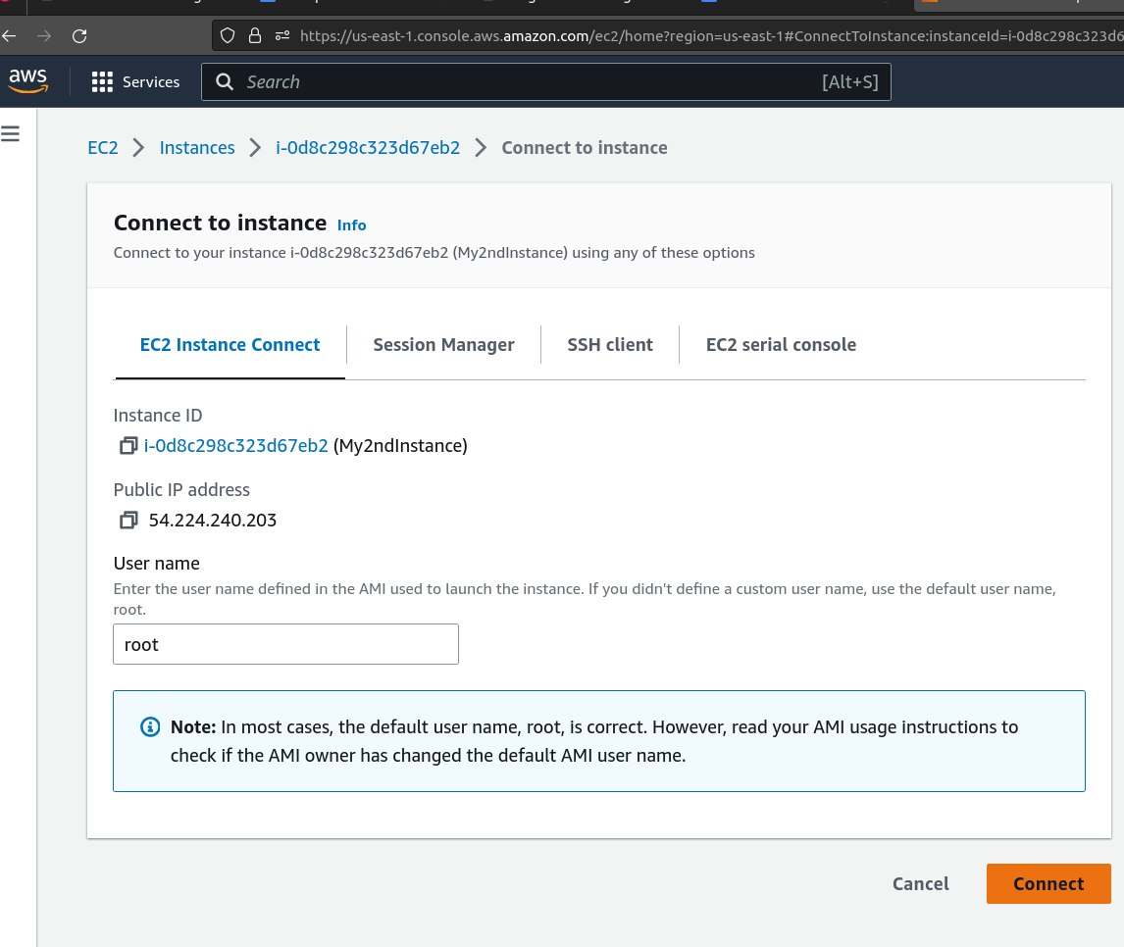

Click on **Connect** at the button right.

The instance would be accessible through the browser as shown below

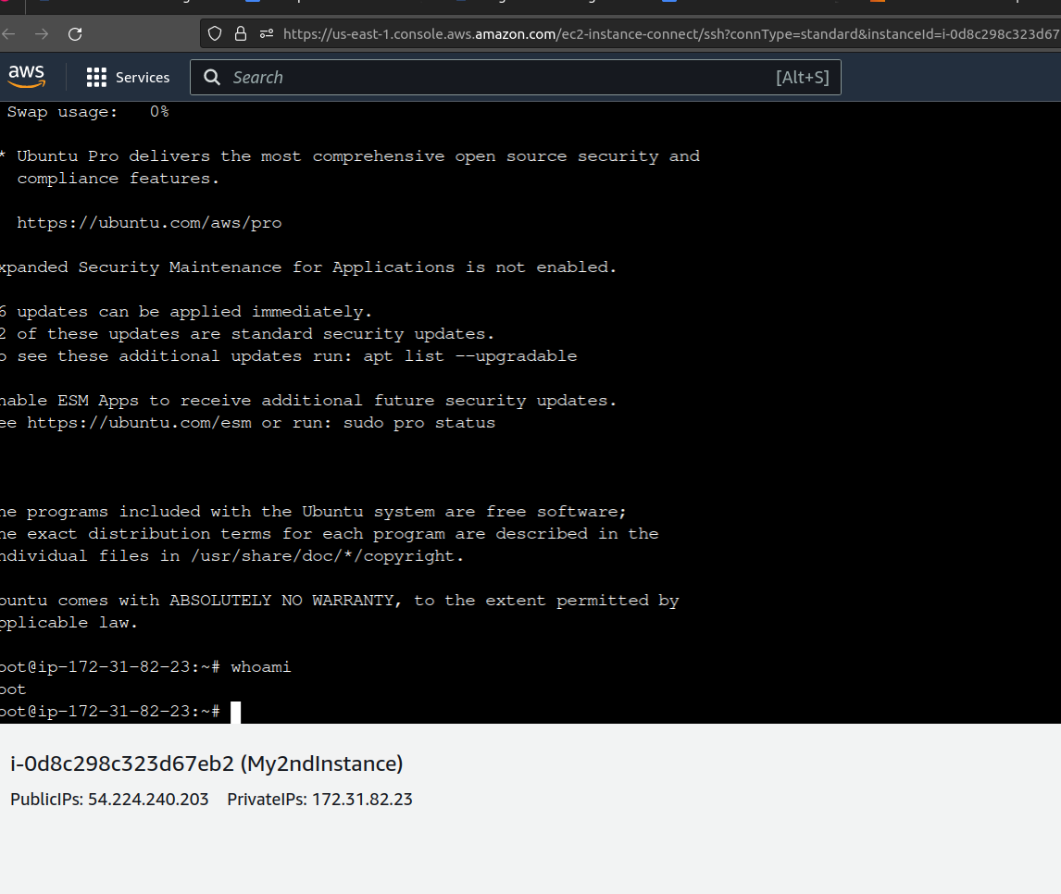

Enter the command

>apache2 -v

The version of apache would reflect as shown below to confirm that Apache2 is already installed in the instance.

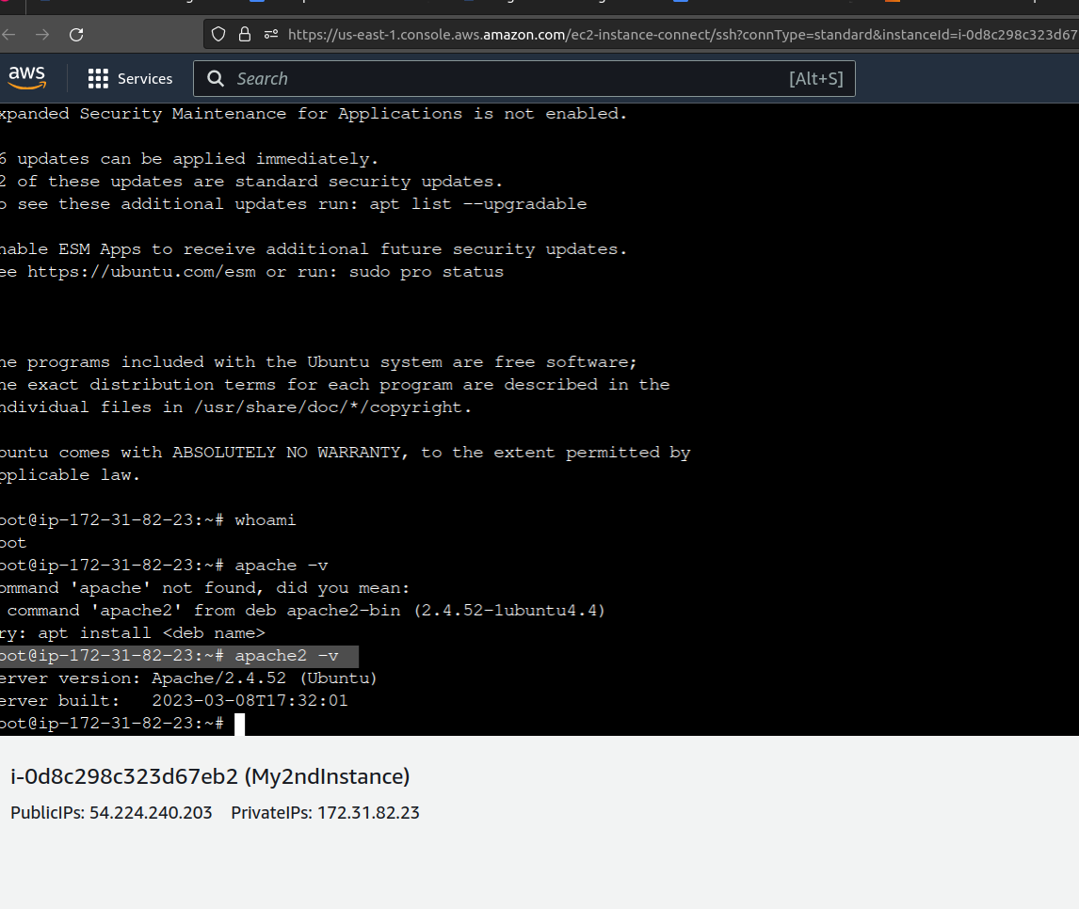

Visit the instance menue and obtain the public IP address as shown below

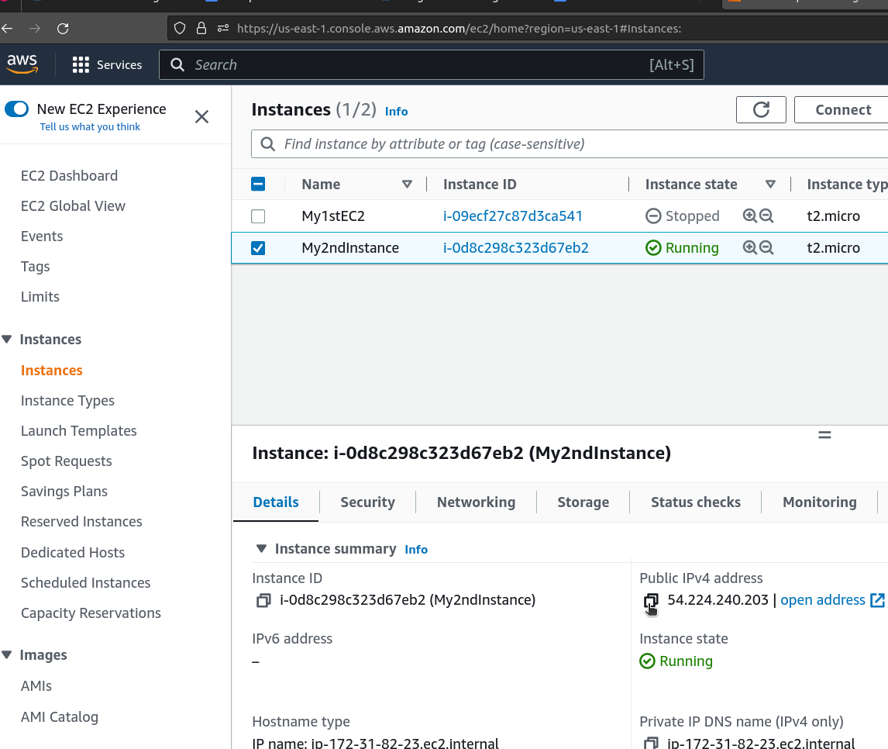

Copy the publick IP address and search the public IP address in the browser address bar.

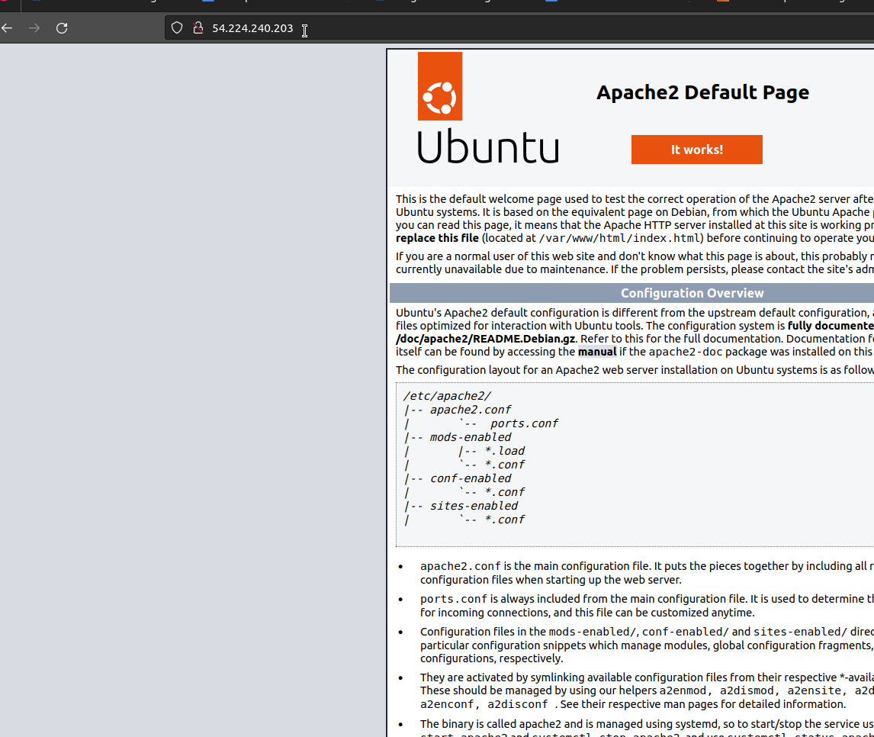

The above page will reflect on the browser confirming that that Apache Server is active and functional.

Congratulations you have successfully accessed the Apache server page from the instance created by your own AMI.

Clean up process.

Visit the Instance menu and Terminate all the instance created.

Terminate the instances by selecting the instances and selecting **Terminate Instance** from the **Instance status** button shown below

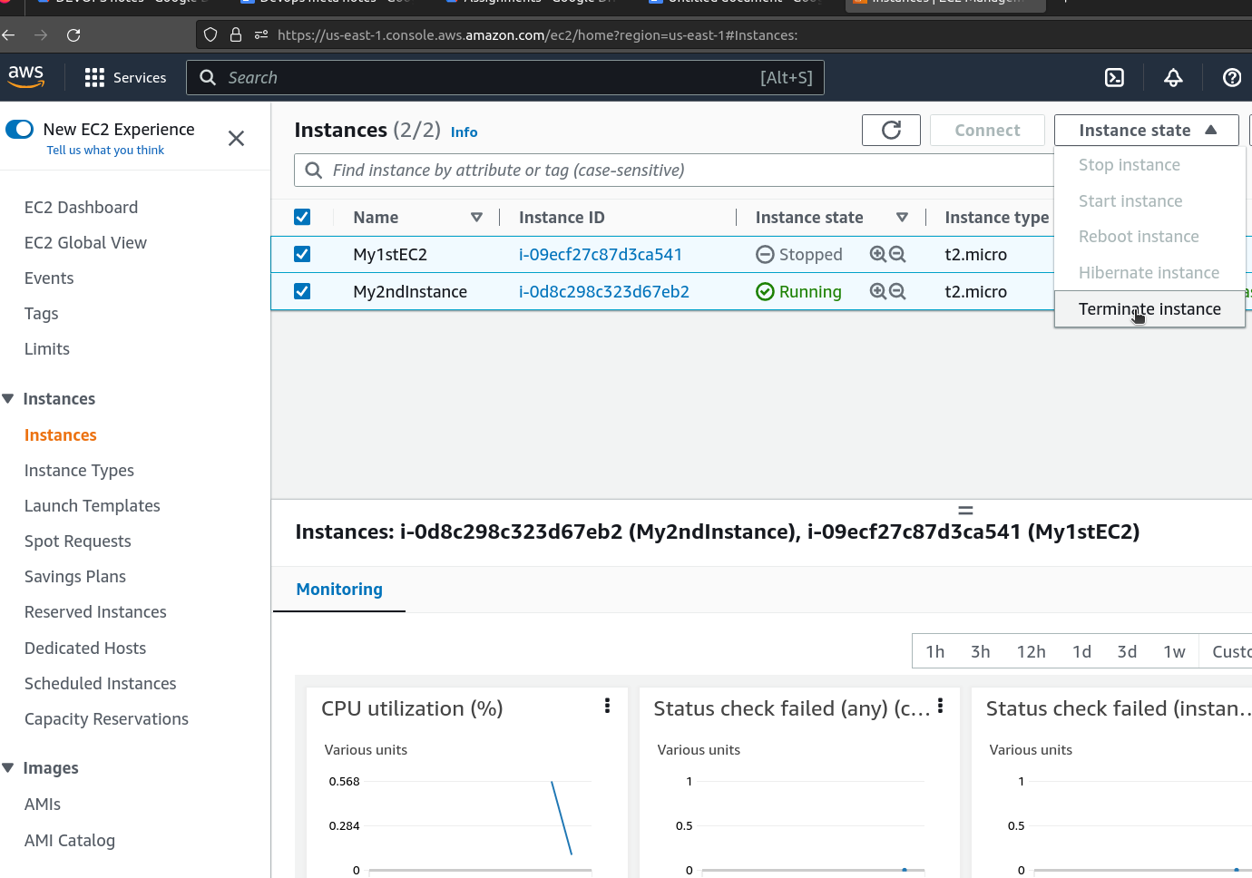

Click on **Terminate** to confirm termination of the instances.

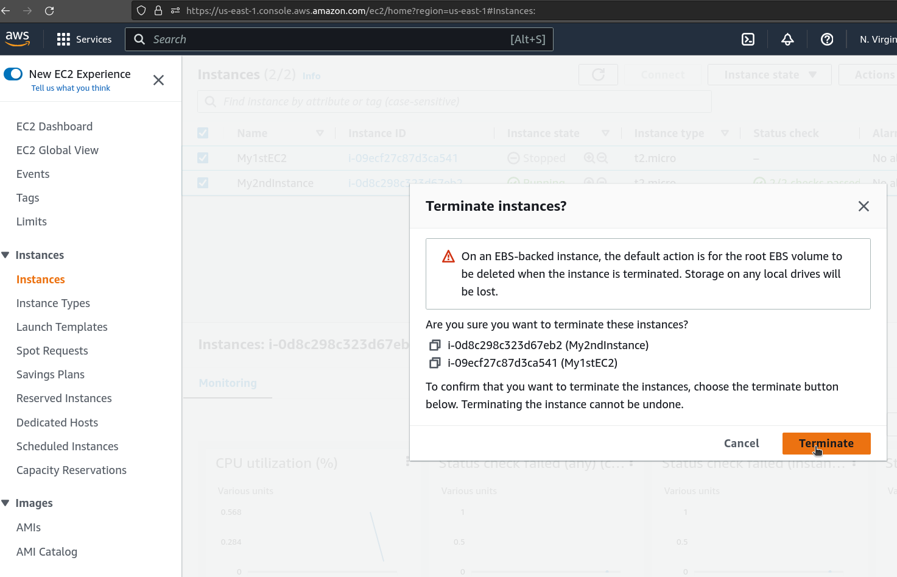

AMI Deregisteration

Visit the **AMI** Sub-menue

Tick the AMI from the AMI list

Click on **Actions** and select **Deregister AMI** as shown below

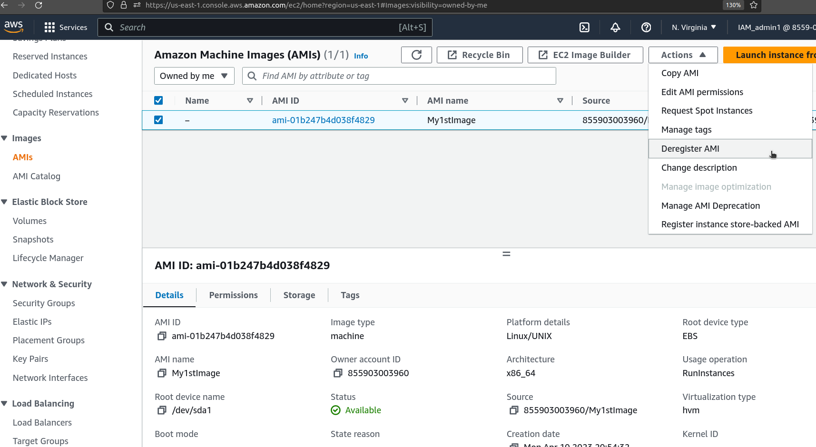

Click on **Dergister** to confirm

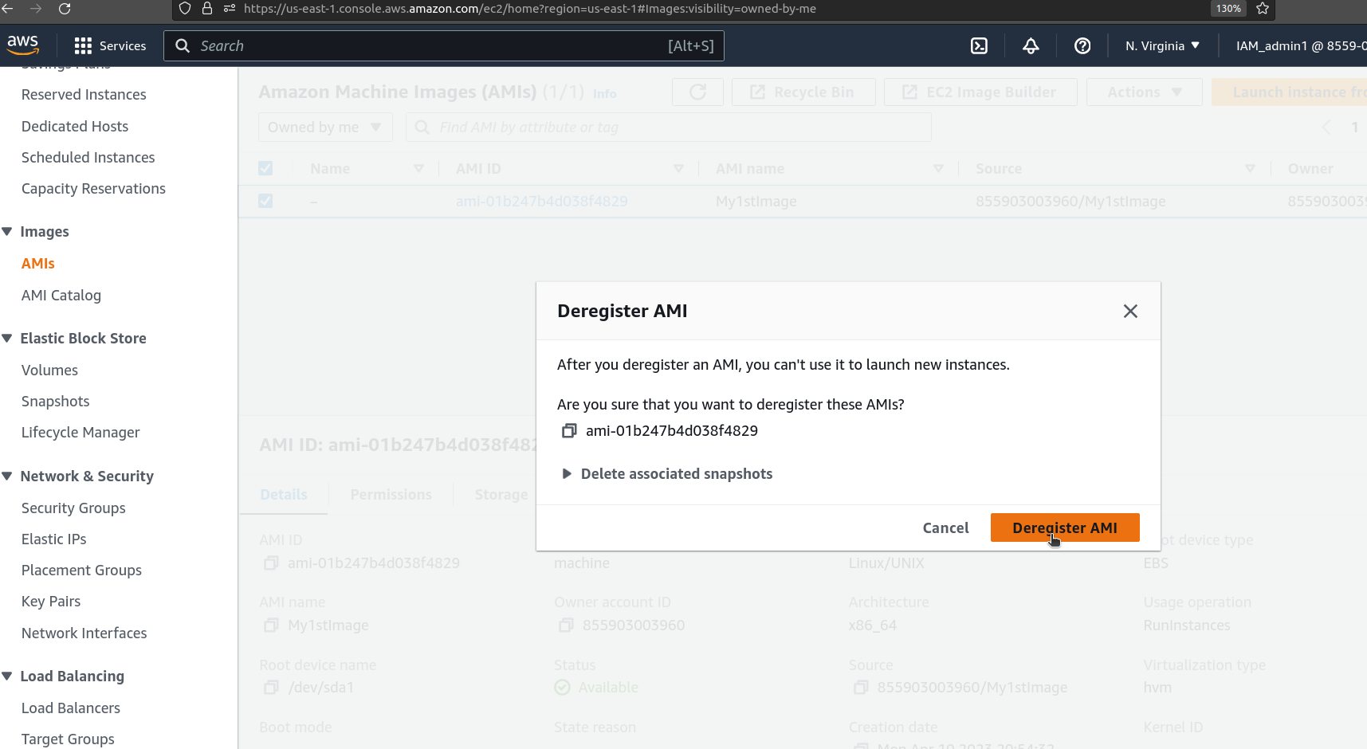

Snapshot Deletion

Visit the **Snapshot** sub-menue

Tick the snapshot from the snapshot list

Click on **Actions** and select **Delete Snapshot** as shown below

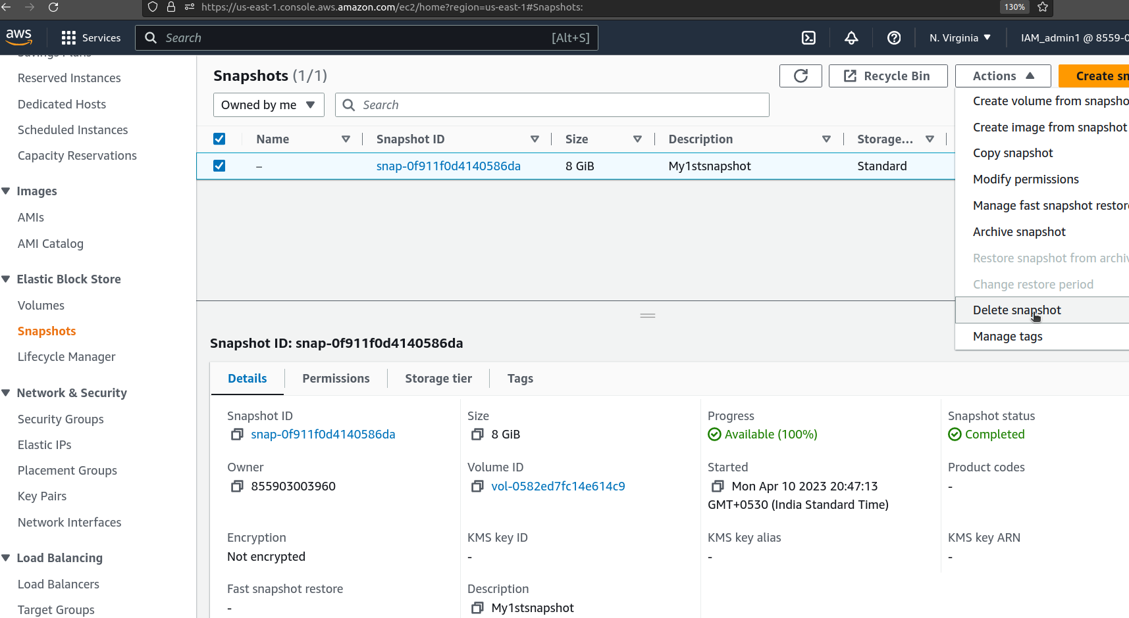

Click on  **Delete** to confirm

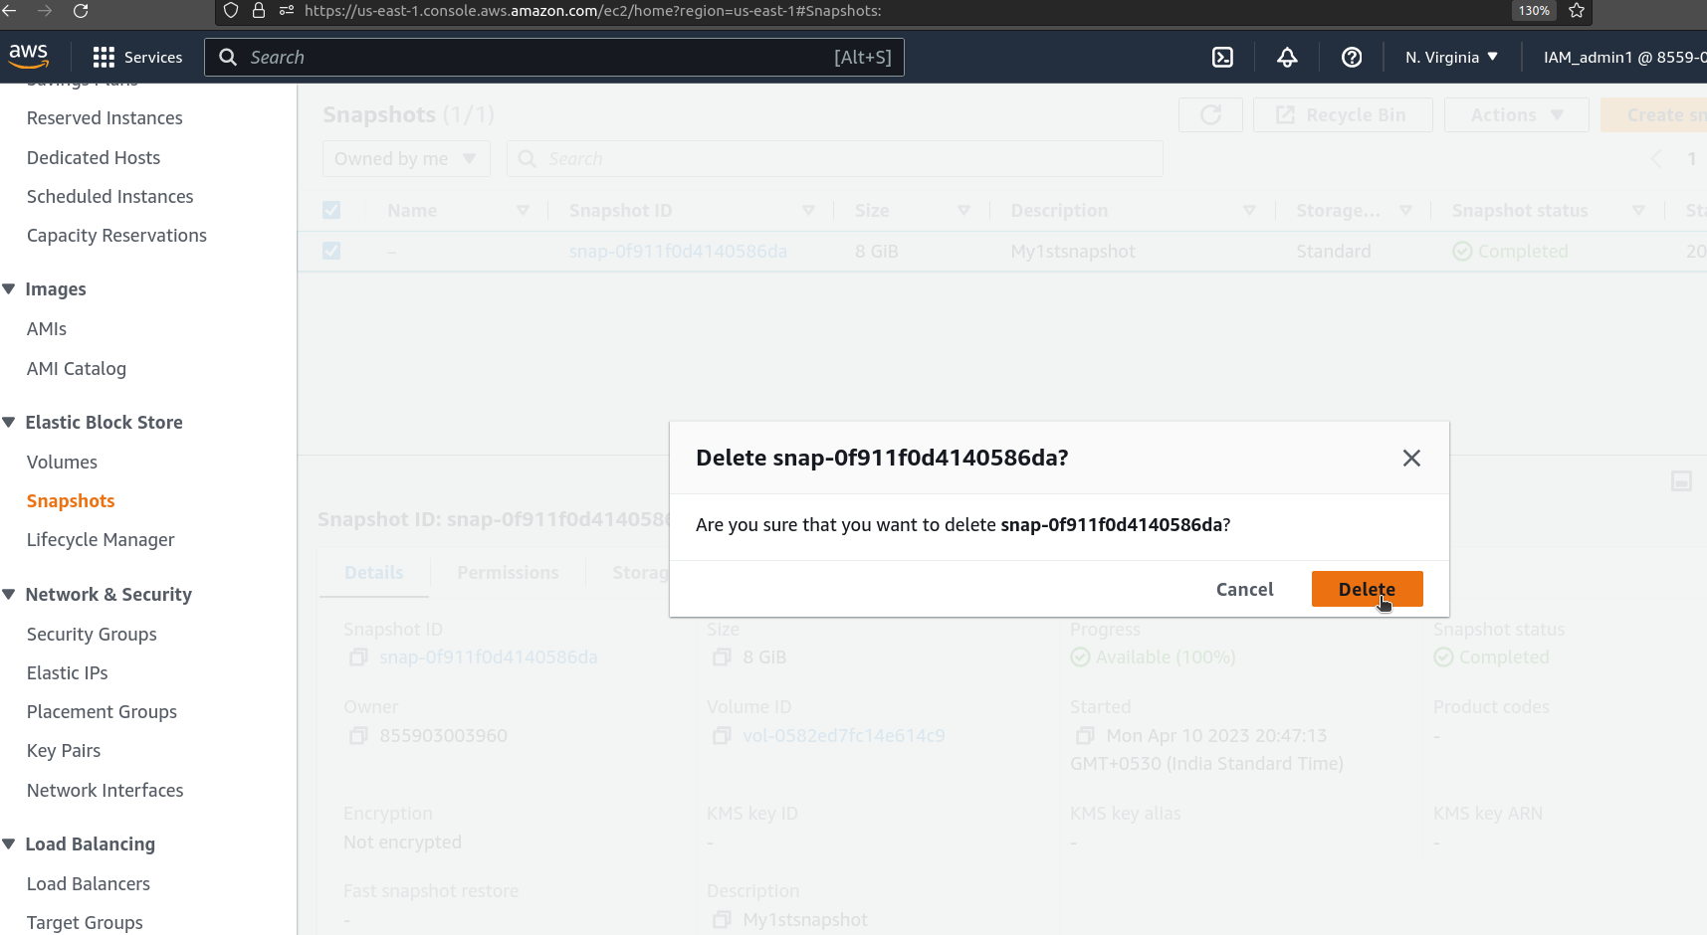

Delete Volume

Visit the **Volume** sub-menue and delete the volume associated to the instance deleted earlier.

Key Pair Deletion

Visit the **Key-Pair** sub-menue and select the key pair associate to instance deleted earlier.

Click on **Actions** and click on **Delete**

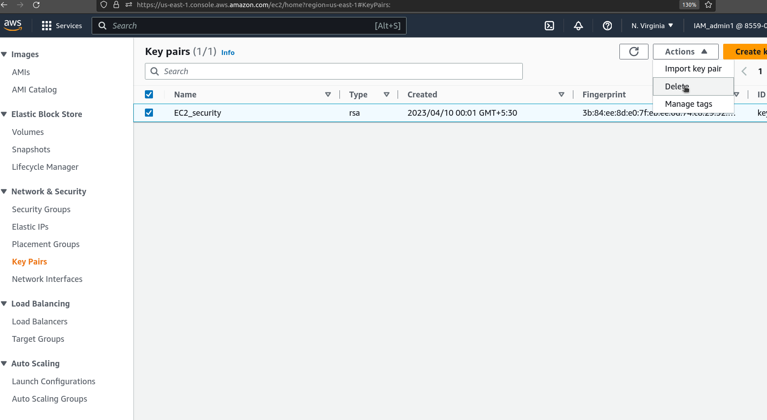

Specify “Delete” and click on Delete to confirm deletion

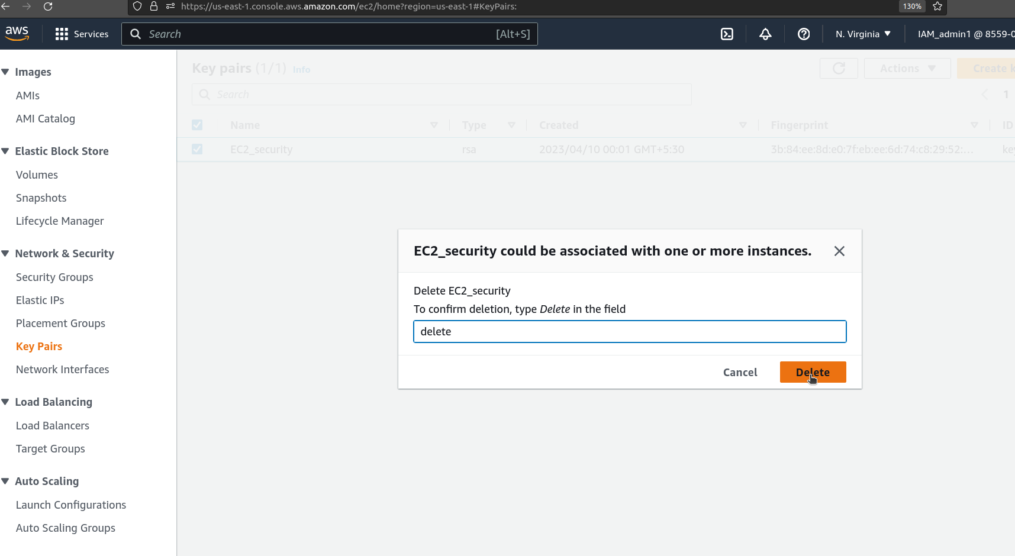

Security Group Deletion

Visit the Security group sub-menue and select the Security group associated to the instance deleted earlier.

Click on **Actions** button , scroll down and select **Delete Security Key** option.

(Note: the Default Security Group cannot be deleted)

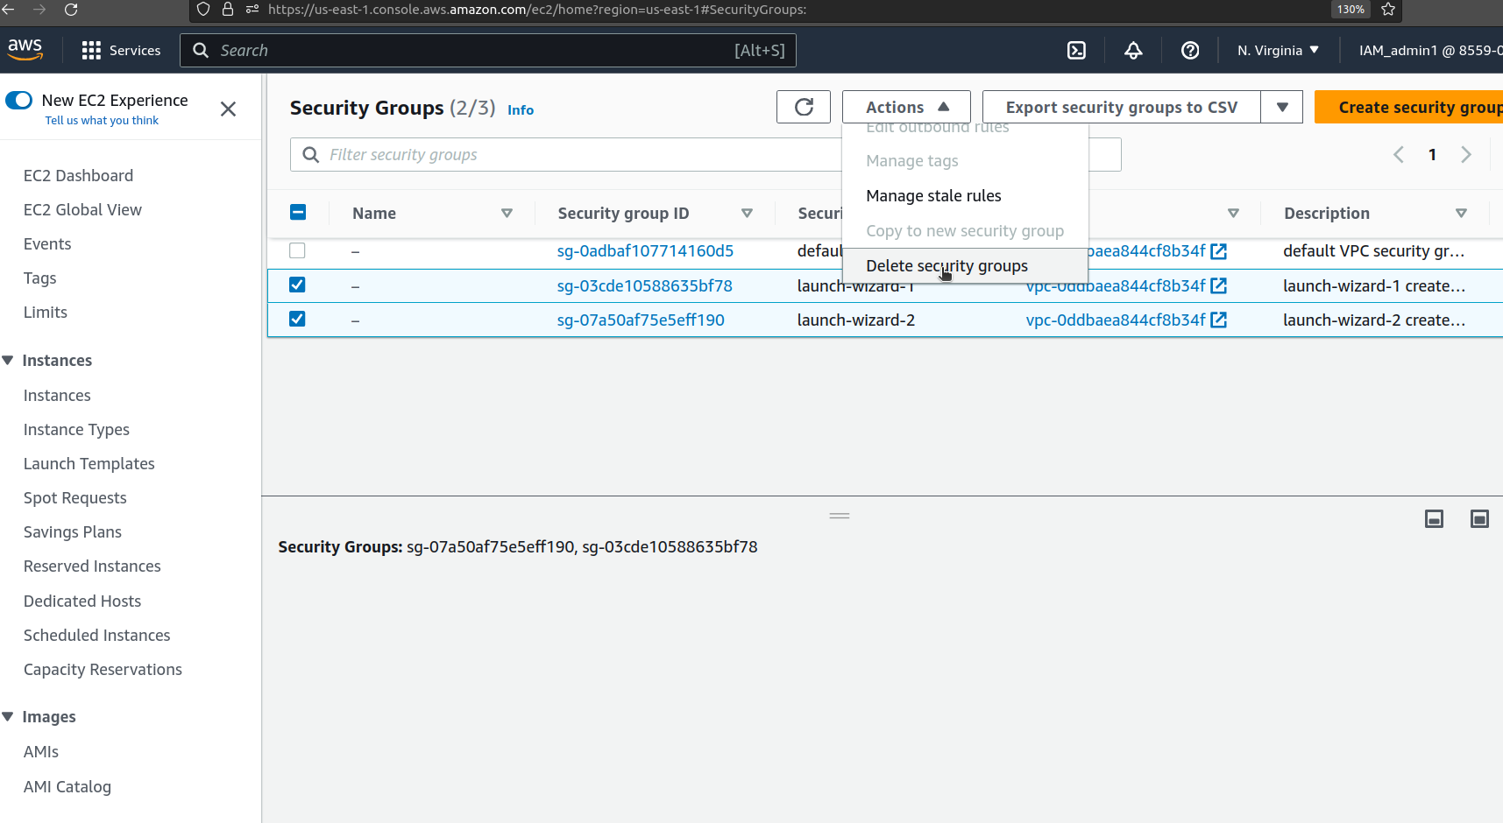

Specify delete and confirm deletion

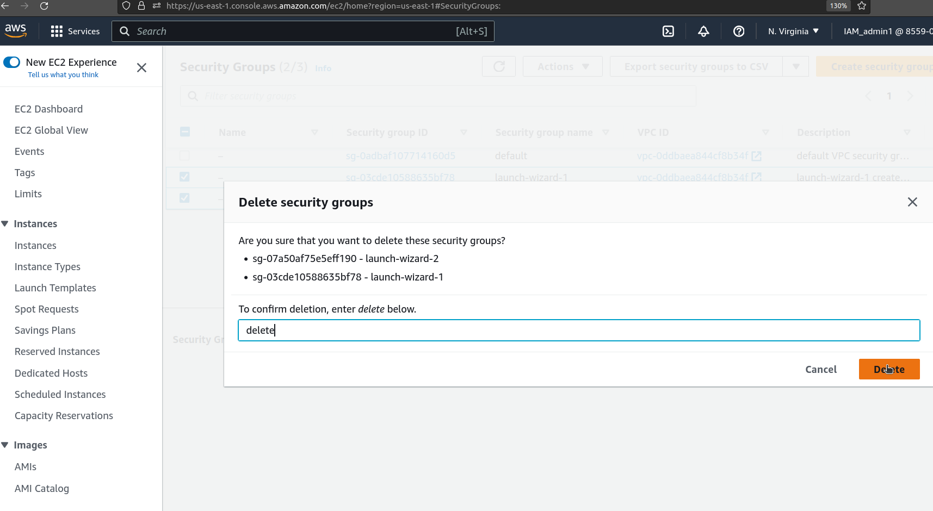

Visit the **EC2 instance Dashboard** to confirm all the services recently used have been cleared from the system.

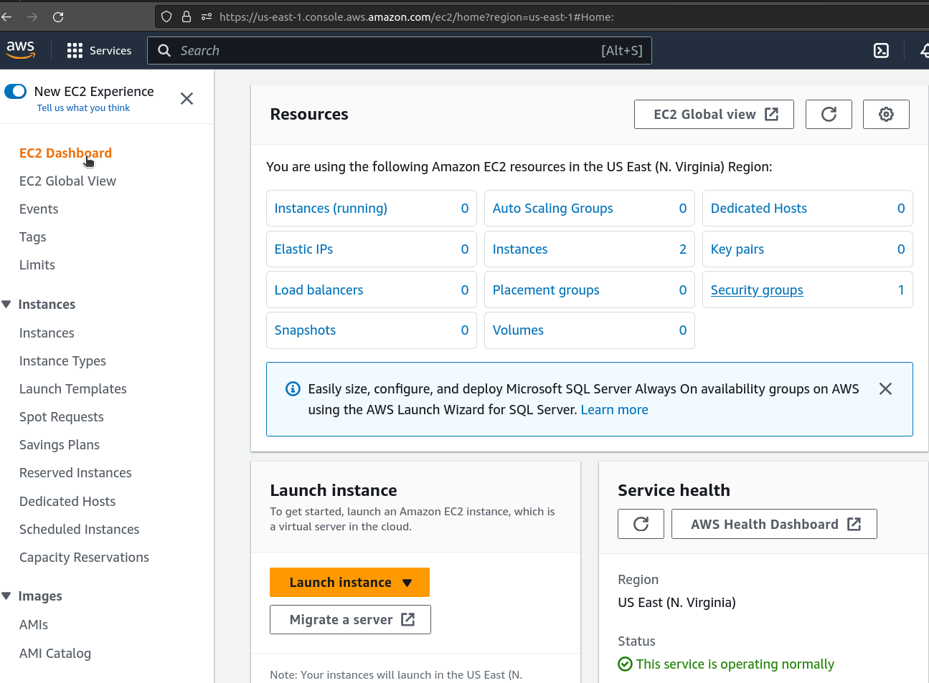

Note: Instance termination would take some time to disappear from the instance list.

Launch more like this.

Multiple instances can be launched with the help of the AMI created with reference to the Instance.

Select an active instance from the list and create an image as shown below

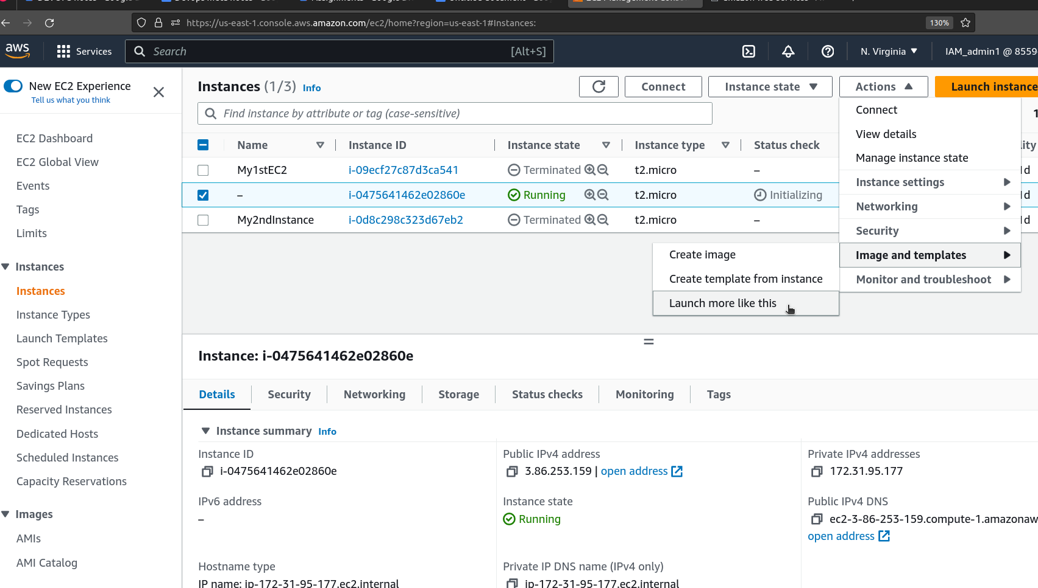

Launching a Windows instance in EC2

To create a Windows instance in AWS

Visit the **Instance** sub-menue under **Instances** menu

Click on **Launch Instance**

FIll in your desired name in the **Name and Tag** section

Click on **Browse more images** and select a windows image which is tagged as in free tiere.

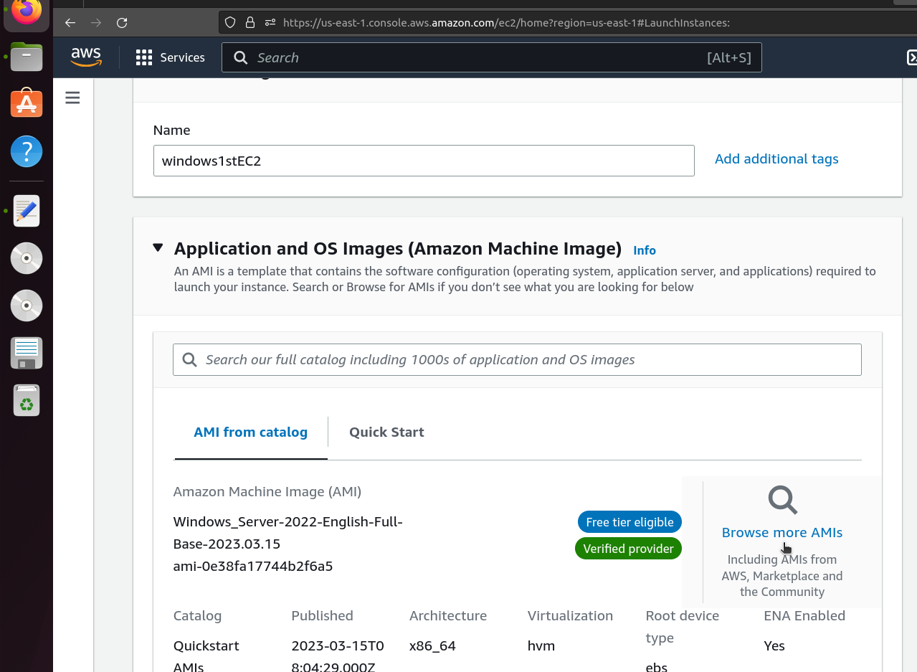

Under **Key Pair** section

Click on **Create new key pair** and specify your desired name.

Click on create new key pair button to confirm and obtain a .pem file

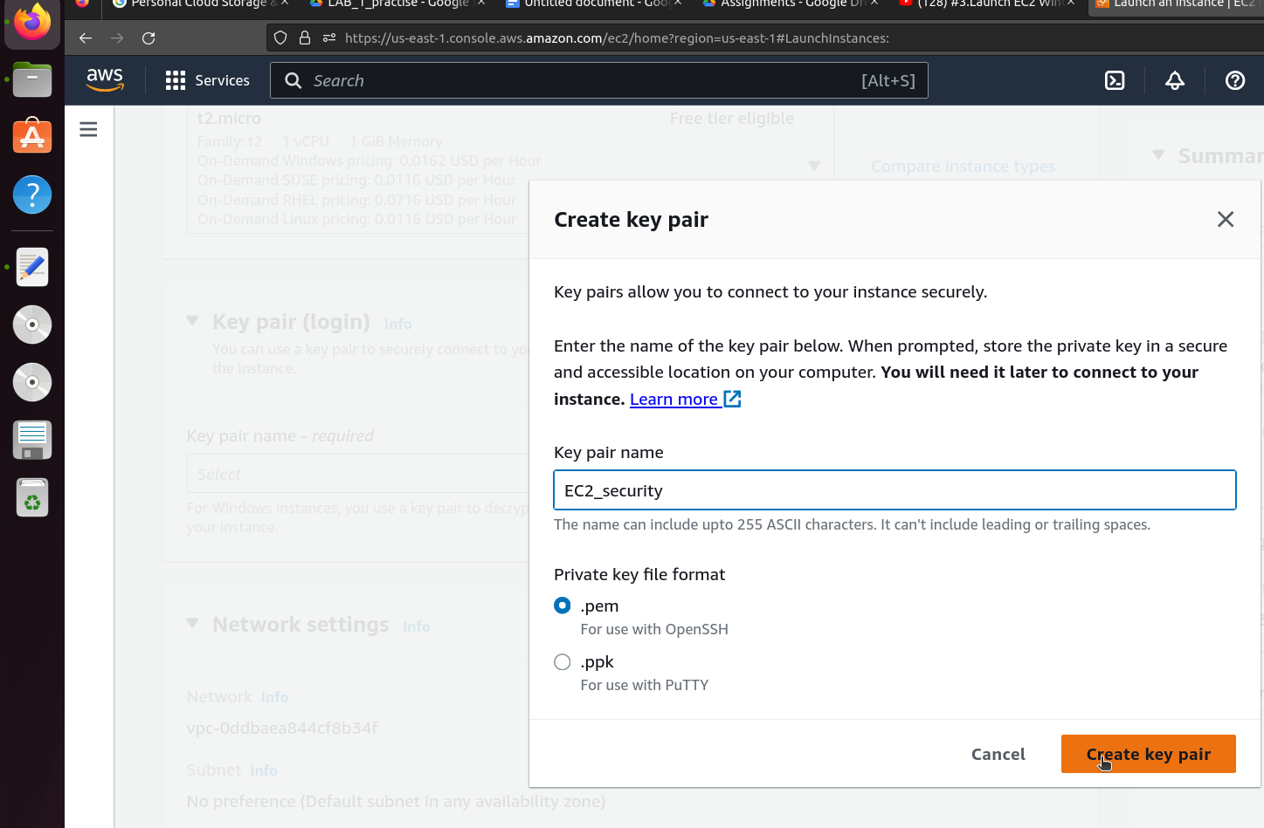

Under Network and settings section, make sure to have ticked the “Allow RDP Traffic” check box.

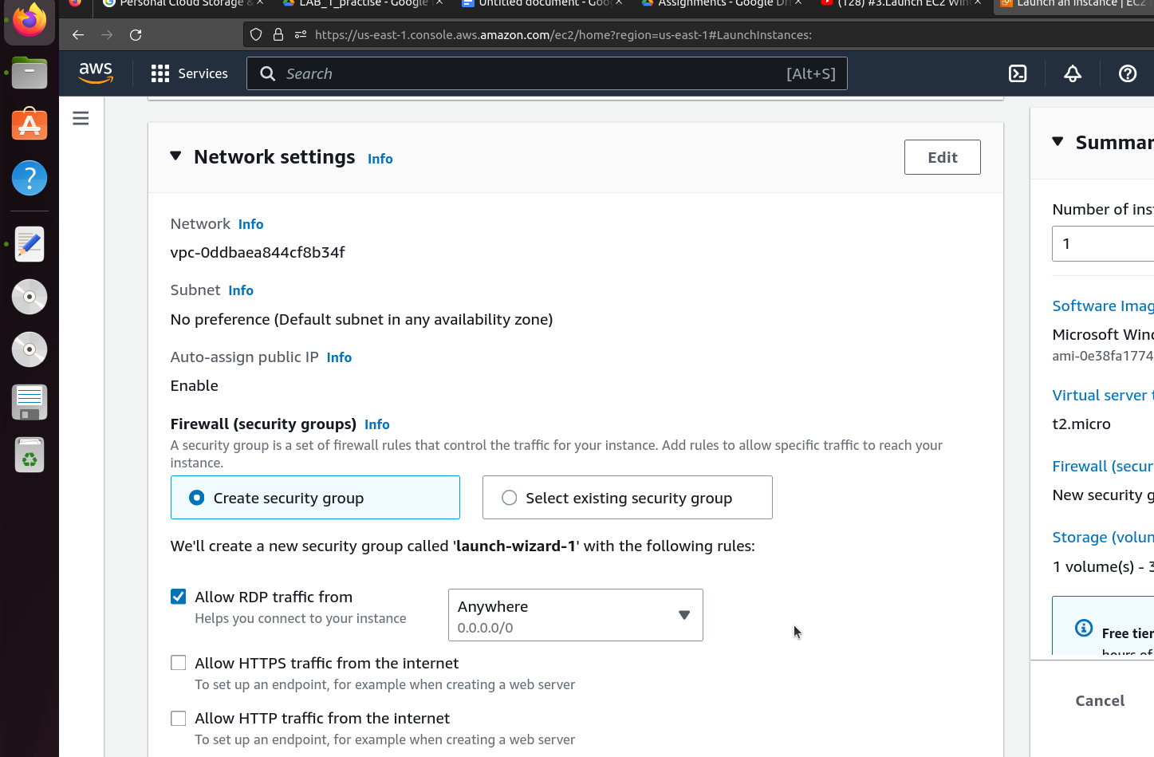

Click on launch instance at the bottom right.

Visit the **Instance** page to confirm whether the Windows instance has been created.

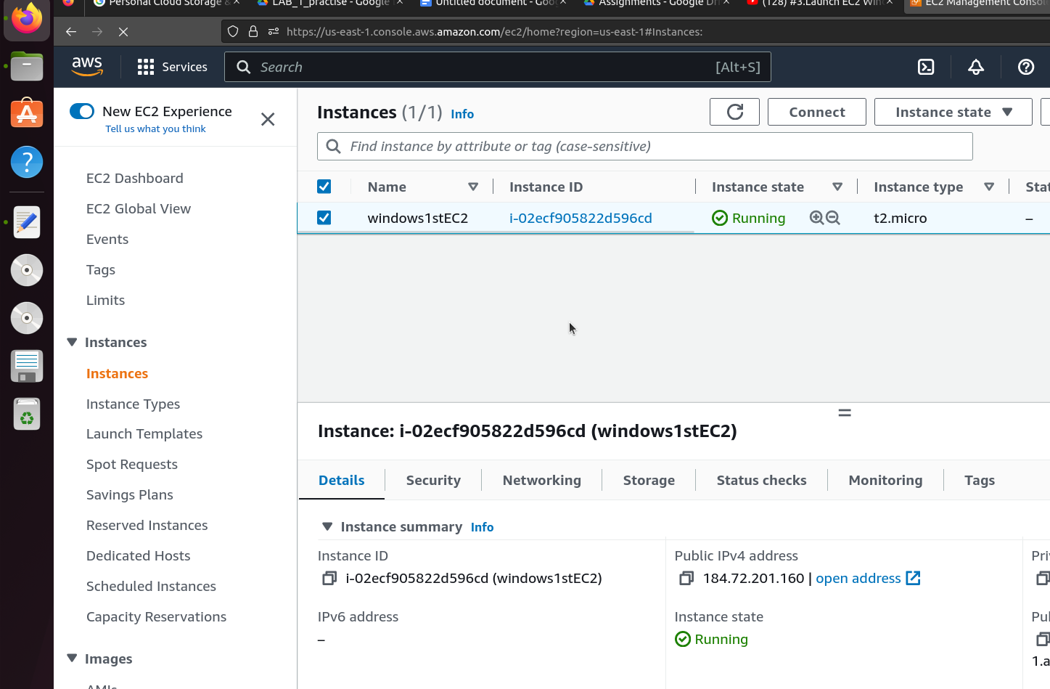

Congratulations you have successfully created a windows instance.

In order to connect to the newly created windows instance, you would require a a tool such as Remmina in ubuntu .

Steps to install Remmina can be found in the link

<https://remmina.org/how-to-install-remmina/>

After successful installation of Remmina.

Gather the instances public address

Open the Remmina tool

Enter the public address in the address field of Remmina tool

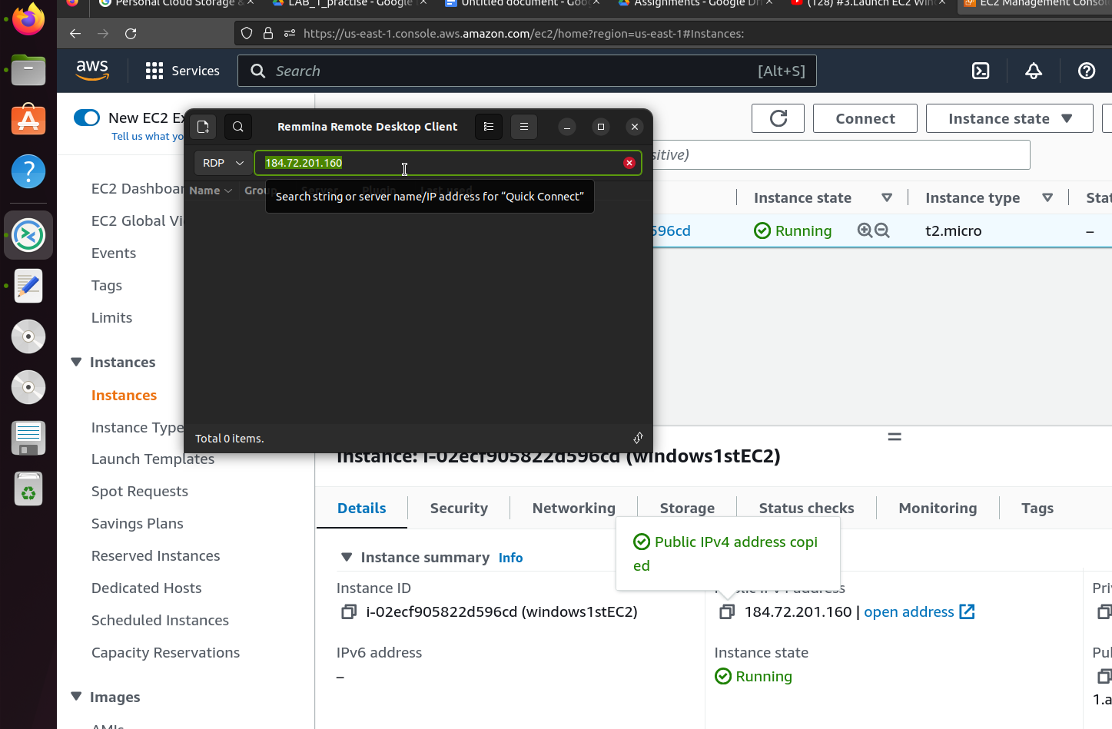

Click on enter

Click on **yes** when you see the below pop up

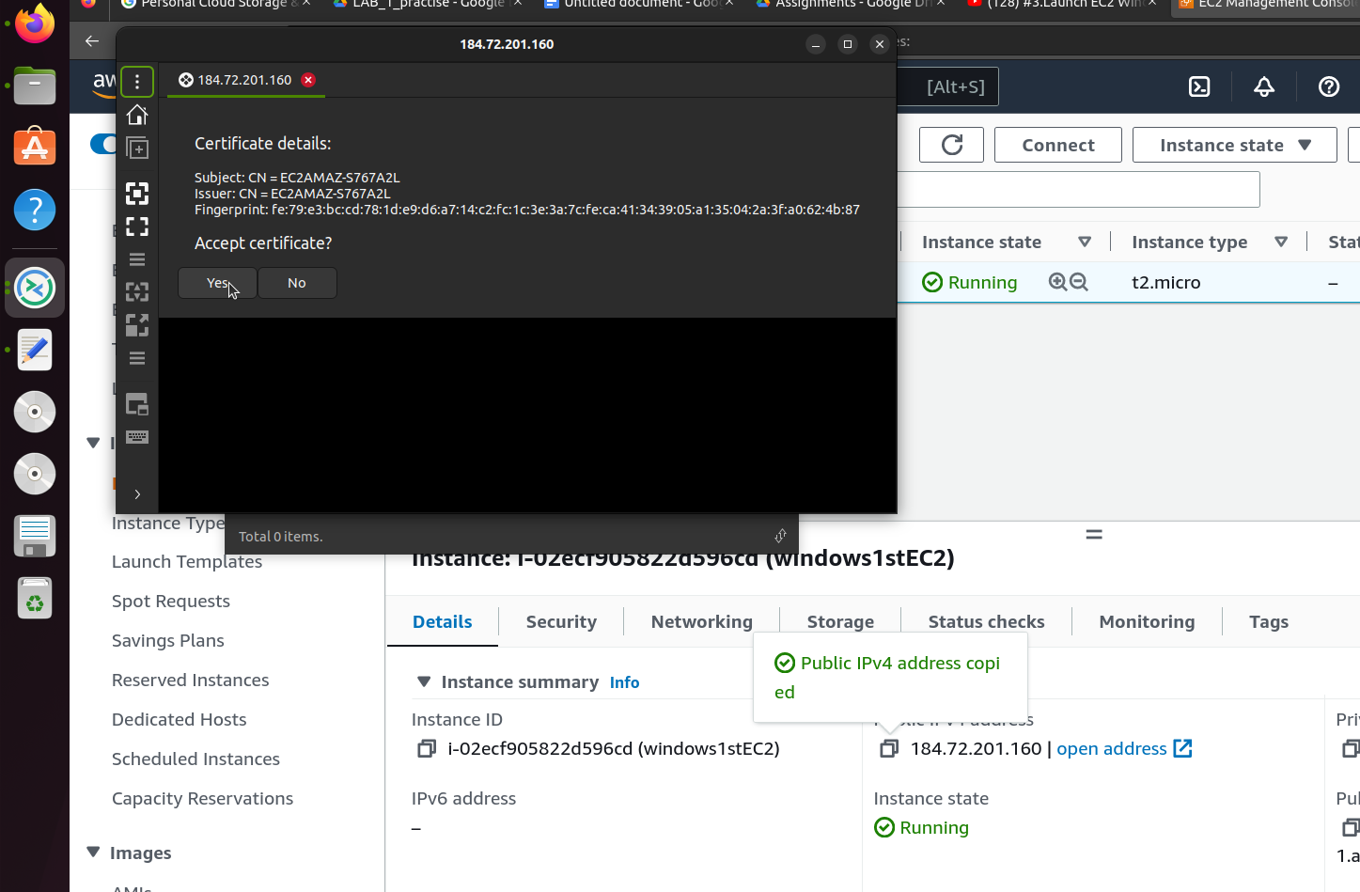

You will receive another popup asking for username and password

Enter

Username: administrator

password can be obtained by performing the following steps

Visit the instance page in the browser and select the windows instance.

Click on **connect** button and switch to the **RDP** Tab

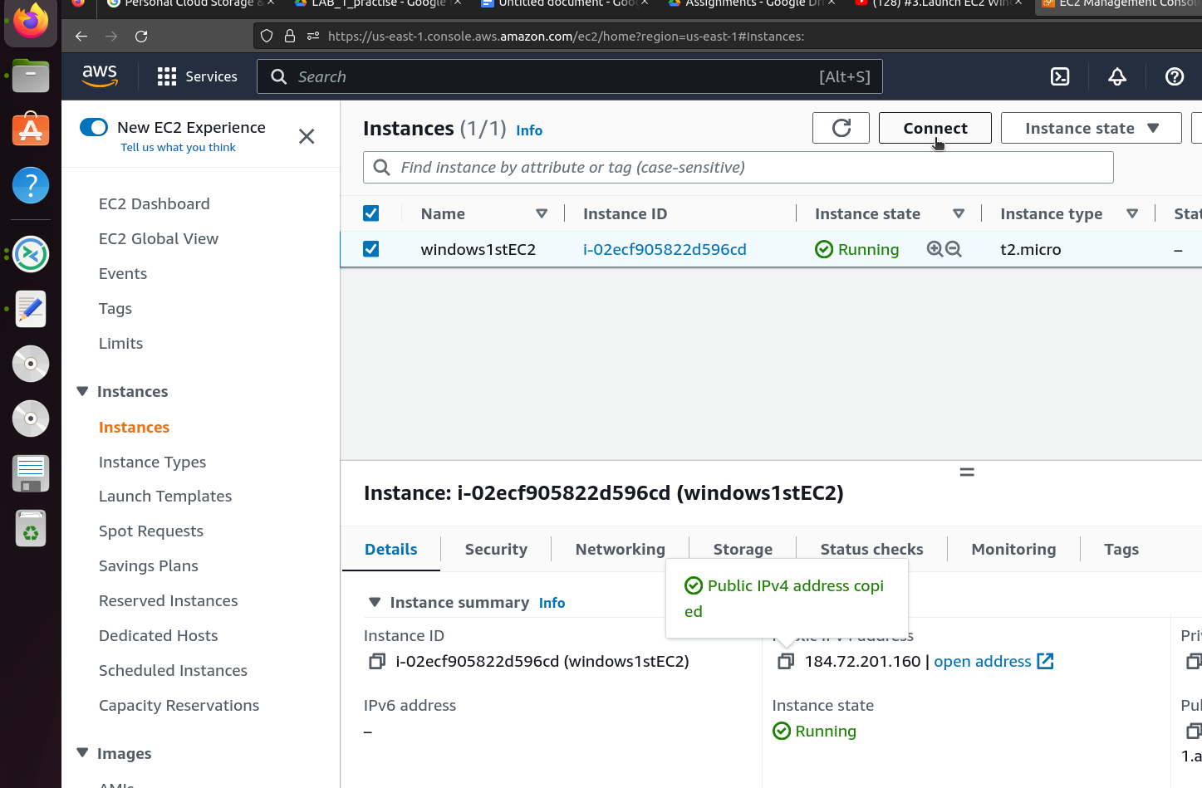

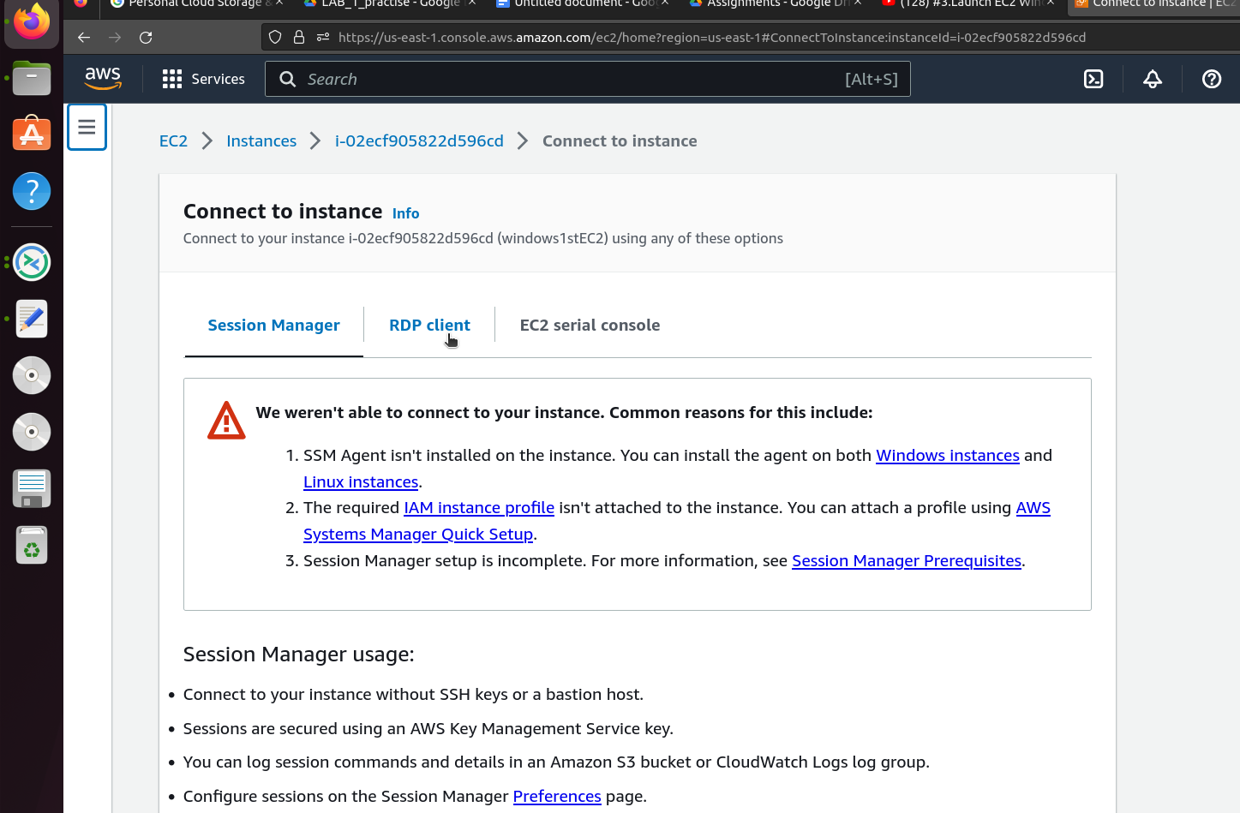

Scroll down and click on **Get password** button

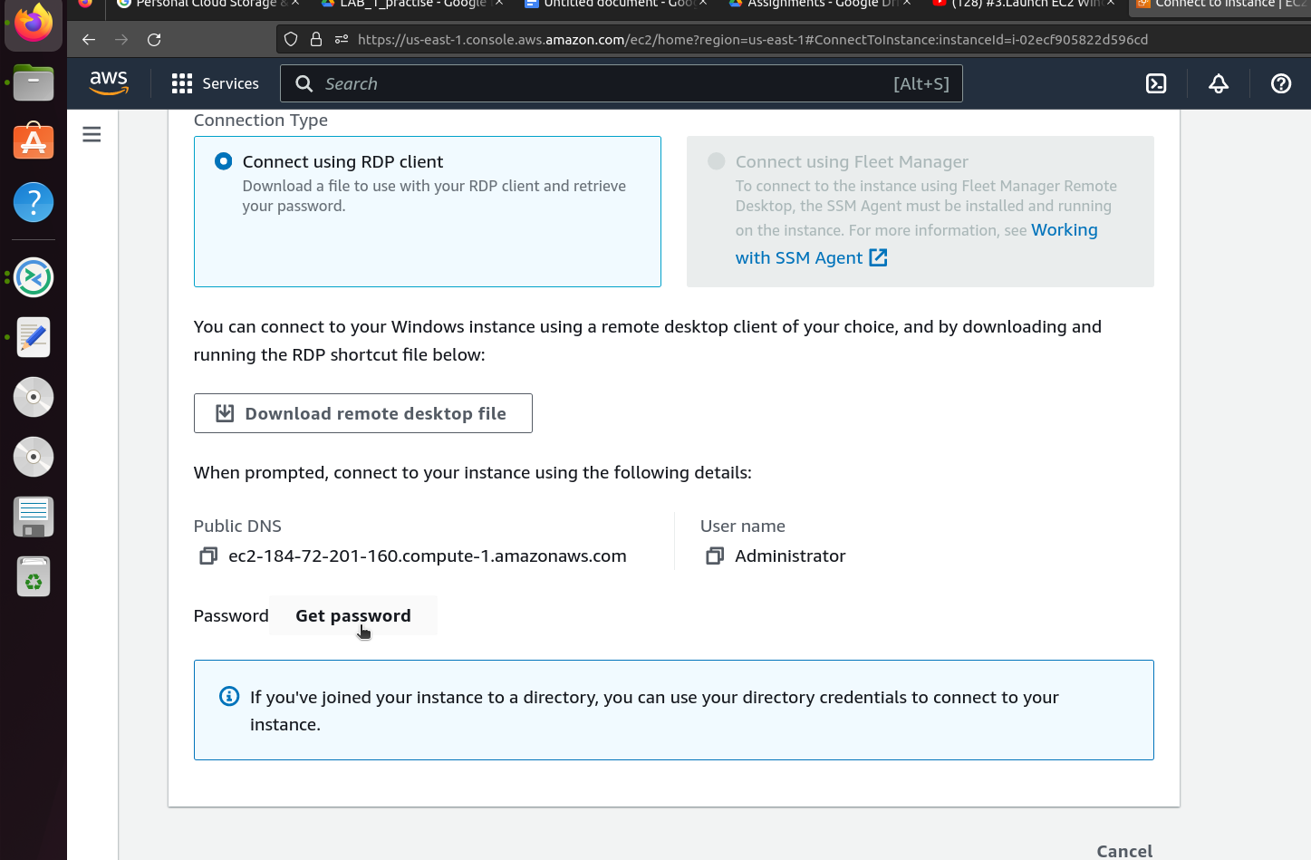

Click on **Upload private key file** and select the .pem file that was downloaded recently

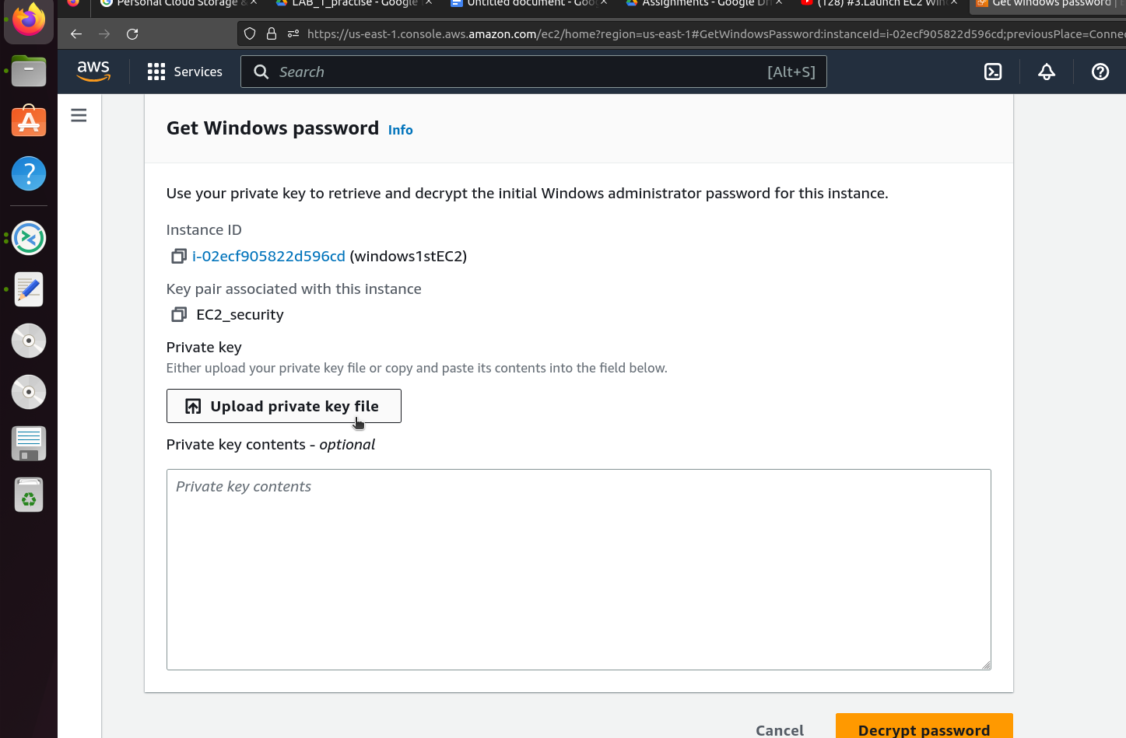

Scroll down and click on **Decrypt password** button

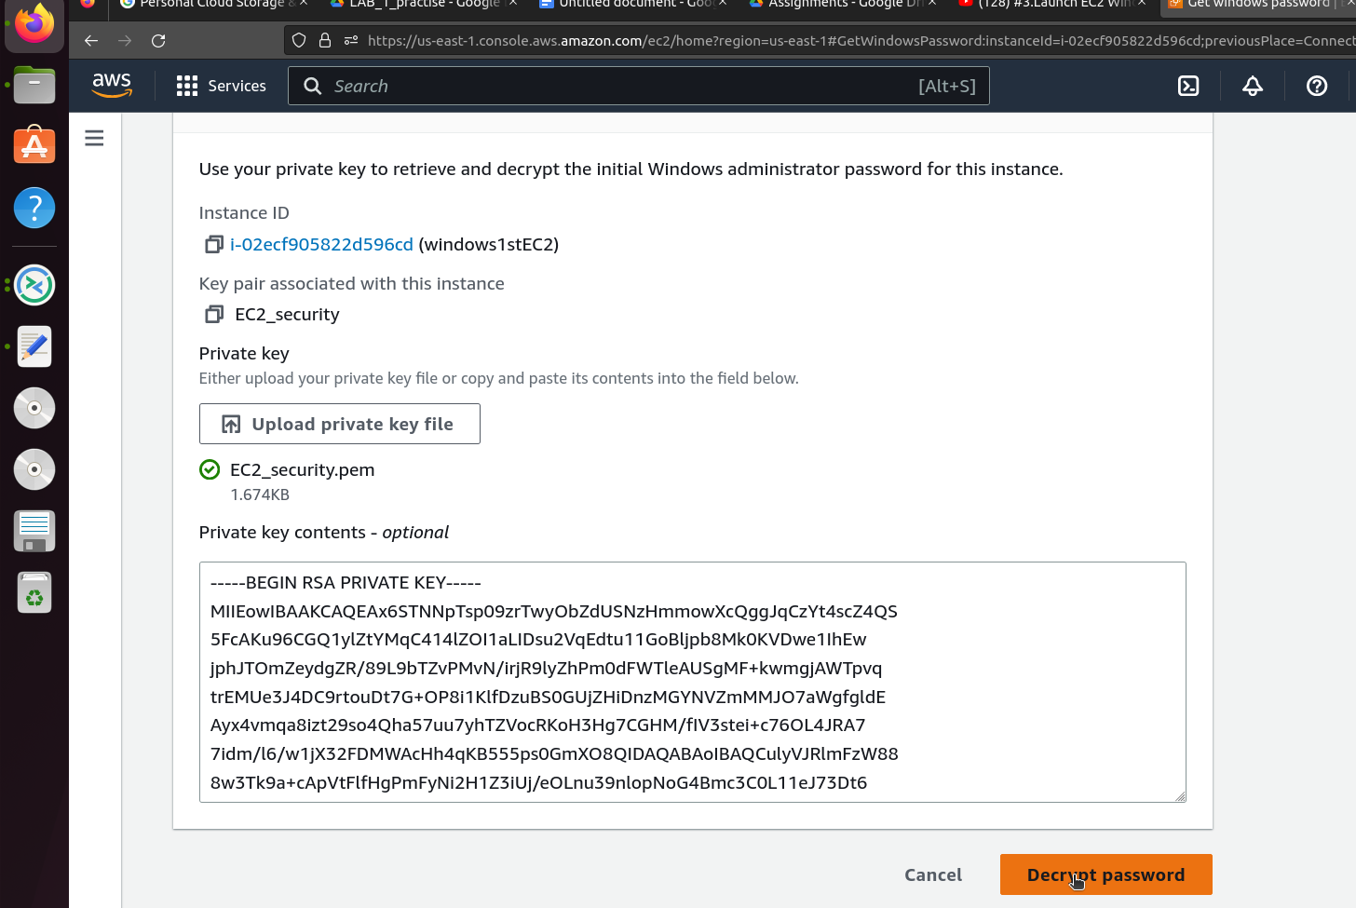

A password will reflect in the password field as shown below

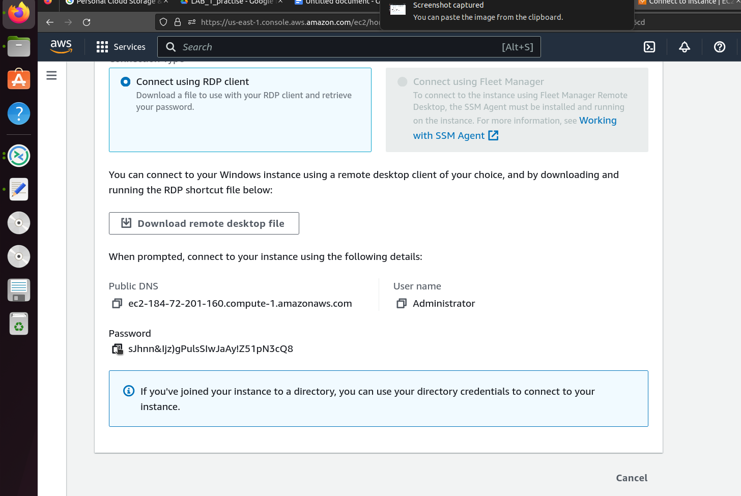

Copy the password to switch to the Remmina user login prompt window.

Enter the username, password and click on **OK** button

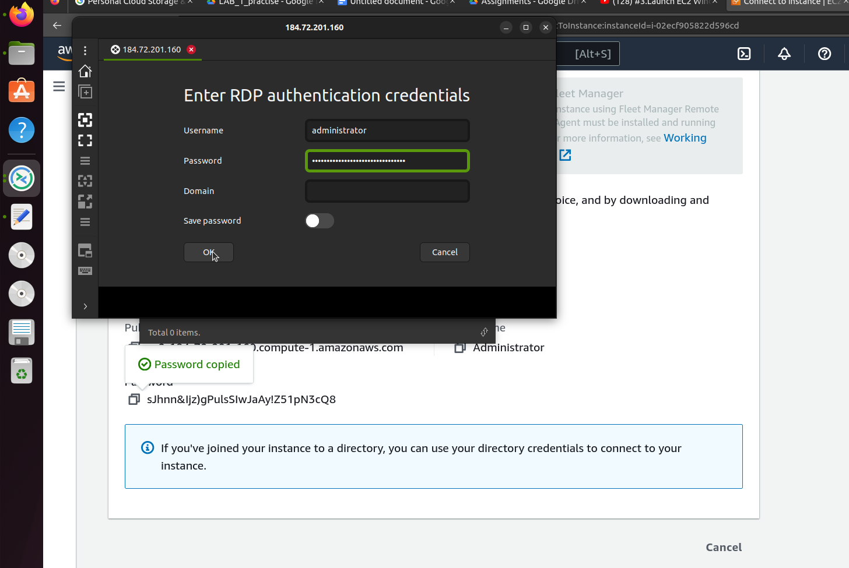

Wait for a couple of minutes and you will receive a window as shown below

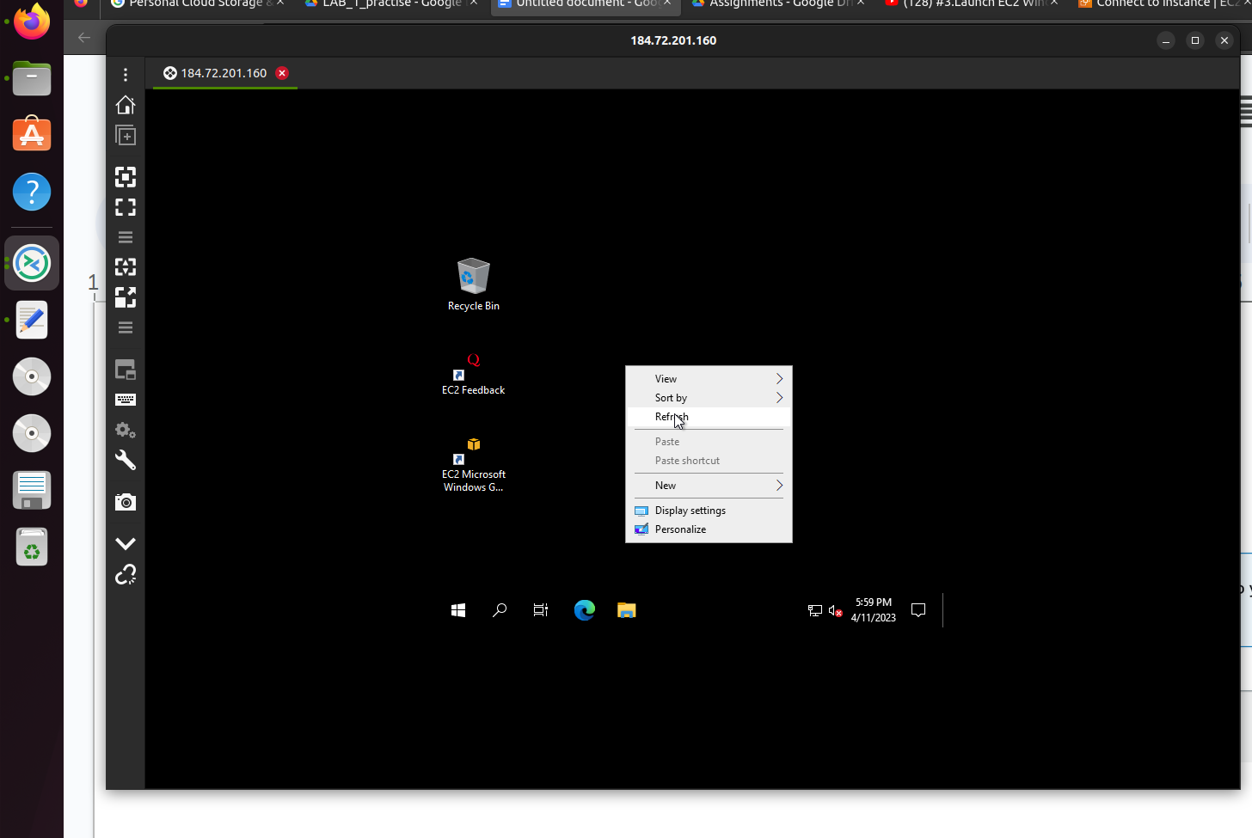

Congratulations you have successfully logged into the newly created windows instance .

